EVALUATION OF METASEAL’S CRYPTOGRAPHIC WATERMARKING PIPELINE AGAINST GEOMETRIC SPATIAL ATTACKS AND LARGE-SCALE SEMANTIC AVERAGING

BY

AGHULOR, DIVINE
(22CG031816)

A PROJECT SUBMITTED TO THE DEPARTMENT OF COMPUTER AND INFORMATION SCIENCES, COLLEGE
OF SCIENCE AND TECHNOLOGY, COVENANT
UNIVERSITY OTA, OGUN STATE.

IN PARTIAL FULFILMENT OF THE REQUIREMENTS FOR THE AWARD OF THE BACHELOR OF SCIENCE (HONOURS) DEGREE IN COMPUTER SCIENCE.

JUNE, 2026

CERTIFICATION
I hereby certify that this project was carried out by AGHULOR DIVINE in the department of Computer and Information Sciences, College of Science and Technology, Covenant University, Ota, Ogun State, Nigeria, under my supervision.

Miss Jemimah Nathaniel
Supervisor Signature and Date

Prof. Aderonke A. Oni
Head of Department Signature and Date

DEDICATION
This project is dedicated to God Almighty, who has been my refuge all my life. I also dedicate this work to my friends and family, who support me and motivate me to be my very best self.

ACKNOWLEDGEMENTS
I would like to say that as much as I would like to have God Almighty to be credited, God Almighty, during the course of this project, remained to me extremely guided, wise, and strong.I would like to give a hearty thanks to my parents, Pst. Omoniyi Akintunde and Dr. Omoniyi Bolaji, out of their love, prayers, encouragement and money, which helped this project to be established. They have acted as the greatest motivator to me by their sacrifices and faith in me.I also owe my supervisor their help, constructive criticism, and valuable feedback which were also instrumental in ensuring the success of this research.I would like to dedicate a special mention to the faculty and the staff of the Department of Management Information Systems, Covenant University, whose support and the knowledge I obtained helped me in my academic life.And last but not least, I would like to note that my friends and colleagues have been very supportive and cooperative and have provided valuable input when this work has been done.

TABLE OF CONTENT
CONTENT PAGES
COVER PAGE Error! Bookmark not defined.
CERTIFICATION ii
DEDICATION iii
ACKNOWLEDGEMENTS Error! Bookmark not defined.
TABLE OF CONTENT Error! Bookmark not defined.
LIST OF FIGURES Error! Bookmark not defined.
LIST OF TABLES Error! Bookmark not defined.
ABSTRACT x

CHAPTER ONE: INTRODUCTION
1.1 Background of the Study ....................................................................................... 1
1.2 Statement of the Problem .................................................................................. 4
1.3 Aim and Objectives of the Study ..................................................................... 6
1.4 Methodology ...................................................................................................... 8
1.5 Significance of the Study .................................................................................. 12
1.6 Study Limitations .............................................................................................. 14
1.7 Project Outline .................................................................................................. 16
CHAPTER TWO: LITERATURE REVIEW
2.1 Preamble .......................................................................................................... 18
2.2 Review of Technology-Enhanced Learning and Predictive Analytics ............... 19
2.2.1 Overview of Technology-Enhanced Learning Environments .................... 19
2.2.2 Learning Analytics and Student Behaviour Modelling .............................. 22
2.2.3 The Role of Data in Predicting Student Performance ................................ 25
2.3 Review of Relevant Concepts ........................................................................ 28
2.3.1 Artificial Intelligence .................................................................................. 28
2.3.2 Machine Learning ....................................................................................... 30
2.3.3 Deep Learning ............................................................................................ 32
2.3.4 Graph Convolutional Networks .................................................................. 34
2.3.5 Natural Language Processing .................................................................... 36
2.3.6 Transfer Learning ....................................................................................... 38
2.3.7 Transformers .............................................................................................. 40
2.3.8 BERT .......................................................................................................... 42
2.3.9 T5 ............................................................................................................... 44
2.4 Comparison of Transformer Models ................................................................ 46
2.5 Review of Related Methods ............................................................................ 49
2.5.1 Traditional Statistical Models ..................................................................... 49
2.5.2 Machine Learning-Based Models ............................................................. 52
2.5.3 Deep Learning Models ............................................................................... 55
2.5.4 Hybrid and Transfer Learning Approaches ............................................... 58
2.5.5 Automated Learning Analytics and Feedback Systems ........................... 61
2.5.6 Engineering Features of Technology-Enhanced Learning Models………
2.5.7 Evaluation Metrics Used in Performance Prediction ................................ 67
2.5.8 Model Performance Trends in Technology-Enhanced Learning Studies ... 70
2.6 Gaps in Related Literature .............................................................................. 73
2.7 Summary of the Literature Review ................................................................. 76

LIST OF FIGURES
FIGURE | TITLE OF FIGURE | PAGES
2.1 | Machine learning diagram | 10
2.2 | Graph Convolutional Networks | 12
2.3 | BERT | 15
2.4 | T5 MODEL | 16
2.5 | Deep learning model | 18

LIST OF TABLES
TABLE | TITLE OF TABLE | PAGES
1.1 | Objective-Methodology Table | 4
2.1 | Hybrid and Transfer Learning  table | 22
2.2 | Evaluation metrics table | 23

ABSTRACT
The rapid proliferation of AI-generated imagery and deepfakes necessitates robust, proactive watermarking systems for cryptographically verifiable image attribution. MetaSeal is a state-of-the-art framework designed for this purpose, embedding content-dependent Elliptic Curve Digital Signature Algorithm (ECDSA) signatures as QR codes within an image's Discrete Wavelet Transform (DWT) domain using an Invertible Neural Network (INN). While MetaSeal has been proven resilient to adversarial forgery, its robustness against geometric spatial manipulations and large-scale semantic averaging attacks remained empirically untested. This study evaluates these vulnerabilities by conducting two large-scale experiments on 1,000 CelebA-HQ face portraits using a unified metric suite comprising Verification Success Rate (VSR), QR Recovery Accuracy, PSNR, SSIM, and LPIPS. Experiment A assessed spatial fragility across five geometric attack classes, centre-cropping, rotation, scaling, horizontal flipping, and affine shear, revealing severe geometric vulnerability. Verification Success Rate collapsed to 0% under a single lossless horizontal flip, rotations above 5°, and scaling below 50%, pinpointing the spatial rigidity of the QR decoding layer as the primary point of failure. Experiment B implemented a novel semantic collision attack by averaging watermark residuals from highly similar images clustered via CLIP embeddings at scales up to N =1,000. This experiment yielded a 0% forgery success rate at all tested scales, empirically validating MetaSeal's core content-dependency security assumption through the destructive interference of image-specific residuals. The study concludes that while MetaSeal successfully guarantees non-transferability against semantic forgery, achieving real-world deployment robustness will require replacing its QR-based payload carrier with a spatially invariant alternative.
Keywords: MetaSeal, Cryptographic Watermarking, Image Attribution, Deepfakes, Geometric Spatial Attacks, Semantic Averaging, ECDSA, Discrete Wavelet Transform (DWT).

CHAPTER ONE
INTRODUCTION

1.1 Background of the Study
The accelerating pace of digital content production, driven largely by advances in deep generative models such as Generative Adversarial Networks (GANs) and diffusion-based architectures, has fundamentally transformed the landscape of visual media integrity. Today, highly convincing facial manipulations, including face synthesis, face swapping, attribute editing, and full-scene reenactment, can be produced at negligible cost and distributed globally within seconds (Tolosana, Vera-Rodriguez, Fierrez, Morales, & Ortega-Garcia, 2020; Verdoliva, 2020). These capabilities, commonly labelled deepfakes, carry profound implications for trust, accountability, and provenance in digital ecosystems, particularly as AI-generated content (AIGC) becomes ubiquitous across news, social media, legal proceedings, and scientific communication (Pei et al., 2026; Rossler et al., 2019).
Two broad responses to this threat have emerged in the research community. The first is passive forensic detection, which attempts to identify tampered or synthetic images after the fact by analysing statistical artefacts, frequency anomalies, or behavioural inconsistencies in the pixel domain (Pei et al., 2026; Verdoliva, 2020). While these methods have achieved impressive benchmark results, they suffer from a fundamental limitation: as generative models improve, the visual cues that detectors rely upon become harder to distinguish, creating an adversarial arms race in which each new detector is quickly invalidated by more sophisticated synthesis (Tolosana et al., 2020; Zanardelli, Guerrini, Leonardi, & Adami, 2022). Moreover, passive detectors offer no means of asserting positive attribution, that is, they can flag an image as suspicious but cannot cryptographically prove who created it or guarantee that an authentic image has not been falsely attributed to a different source.
The second response is proactive or active authentication, which seeks to embed identity and provenance information directly into images at creation time. Active approaches include fragile watermarking, which is designed to break under any modification, semi-fragile watermarking, which distinguishes malicious tampering from benign operations, and robust watermarking, which aims to survive aggressive post-processing while preserving a recoverable identifier (Senol, Elbasi, Topcu, & Mostafa, 2023; Zanardelli et al., 2022). Among these, semi-fragile schemes that operate in transform domains such as the Discrete Wavelet Transform (DWT) or Discrete Cosine Transform (DCT) are particularly attractive for attribution, as they can survive common perceptual operations such as JPEG compression and mild smoothing while remaining sensitive to content-altering manipulations (Al-Otum, 2014; Hernández-Joaquín, Melendez-Melendez, & Cumplido, 2023; Senol et al., 2023).
Despite these advances, existing authentication schemes have faced a persistent challenge: the watermark is typically not bound to the specific content of the host image. Without this binding, a sophisticated attacker can mount replay or mixup attacks, in which a valid watermark extracted from one authentic image is transferred to a forged or unrelated image, thereby laundering the forgery with a legitimate cryptographic credential. This vulnerability was systematically documented by recent work showing that even state-of-the-art defensive watermarking schemes can be entirely defeated by spectral adversarial attacks that require no knowledge of the watermarking system (Kassis & Hengartner, 2025). The scale of this problem is underscored by frequent reports of generative AI misuse for deepfake creation and the growing calls from regulators and standards bodies for reliable technical mechanisms for digital provenance.
It is within this context that MetaSeal was introduced as a novel framework for content-dependent watermarking with cryptographic security guarantees (Zhang, Wang, & Zhou, 2017a). MetaSeal departs from prior attribution schemes by generating signatures that are cryptographically bound to the semantic content of each image, using Elliptic Curve Digital Signature Algorithm (ECDSA) keys, embedding those signatures as QR codes in the DWT frequency domain through an Invertible Neural Network (INN)-based pipeline, and enabling publicly verifiable extraction without a reference image. MetaSeal has been evaluated against forgery attacks, including Replay, Mixup, and Projected Gradient Descent (PGD) adversarial perturbations, as well as a suite of benign transformations, demonstrating strong resistance across these scenarios.
However, two important and previously untested attack classes remain uncharacterized. First, MetaSeal's DWT embedding and QR code recovery pipeline is inherently dependent on spatial grid alignment, since DWT decomposition operates on fixed-size blocks and QR decoding requires precise spatial boundaries for symbol detection. Geometric and spatial manipulations, including aggressive centre-cropping, rotation, scaling, horizontal flipping, and affine warping, directly disrupt this alignment in ways that differ fundamentally from the pixel-domain noise and adversarial perturbations already studied. There is currently no evidence in the literature on whether MetaSeal's verification chain survives such transformations or collapses entirely. Second, MetaSeal's security guarantee rests on the assumption that its content-dependent ECDSA signatures are non-transferable because they are tied to the semantic caption of each image. Yet, if a large population of semantically similar images (for example, near-duplicate frontal face portraits) are all watermarked under nearly identical semantic contexts, their individual residual watermark signals may carry consistent patterns that could survive averaging, potentially enabling a semantic collision attack that forges a valid QR-decodable signature on a clean target image without breaking ECDSA directly. This possibility has never been tested at scale.
This project directly addresses these two gaps by conducting the first formal empirical evaluation of MetaSeal's robustness against geometric spatial attacks and large-scale semantic averaging. Using the CelebA-HQ dataset at 256×256 resolution and the official MetaSeal inference pipeline running on a Google Colab T4 GPU, the study systematically quantifies verification survival rates, QR recovery accuracy, and perceptual quality metrics across all attack configurations, evaluating two falsifiable null hypotheses. The outcomes of this study, whether MetaSeal is confirmed as robust or a concrete vulnerability is identified, constitute a publishable contribution to the watermarking and digital media integrity literature.

1.2 Statement of Problem
The propagation of AI-generated and AI-manipulated imagery has created an urgent need for cryptographically verifiable image attribution systems that can survive real-world transformations and resist sophisticated forgery attempts (citation needed). Previous studies have tried to address this gap that exist in watermarking using tools such as Marksweep (Zhou et al., (2026), DWT(Ganic & Eskicioglu, 2004; Hernández-Joaquín et al., 2023), the results show that these tools are still susceptible to semantic averaging attacks. Though tools such as MetaSeal was created to address the already existing vulnerabilities in previous watermarking system, resting on the assumption that each image's ECDSA signature is uniquely bound to that image's semantic caption, it yet to be tested against geometric, spatial manipulation, and large scale semantic averaging attacks.
Geometric operations and spatial manipulation such as aggressive centre-cropping, rotation by varying angles, resolution scaling, horizontal flipping, and affine shear transformations directly disrupt this grid alignment in a manner qualitatively different from the adversarial perturbations already evaluated by (Zhou et al., 2026). Additionally, in datasets of semantically homogeneous images, such as a large collection of frontal face portraits with nearly identical descriptive captions, the signed message strings may be functionally near-identical across many images (Hu & Xiang, 2021; Tang, Wang, Xiang, & Cheung, 2024; T. Wang, Huang, Cheng, Ma, & Wang, 2023). If the INN-embedded watermark residuals carry consistent spatial patterns in these conditions, averaging the residuals from a sufficiently large number of near-duplicate images could produce a transferable signal that, when added to a clean target image, yields a QR pattern decodable as a valid existing ECDSA signature. This would constitute a semantic collision attack, not a cryptographic break, but a practical forgery pathway that exploits the statistical regularities of large-scale, semantically homogeneous watermarked datasets. The feasibility of this attack at scales of N = 50, 200, 500, and 1,000 images has never been empirically examined.
The absence of empirical evidence for either of these attack classes leaves a meaningful gap in the security evaluation of MetaSeal and, more broadly, in the community's understanding of the conditions under which content-dependent cryptographic watermarks are vulnerable. This project is designed to close both gaps through a principled experimental investigation with clearly defined null hypotheses, shared evaluation metrics, and results that are interpretable under either outcome.
----------------------------------------------------------------------

The propagation of AI-generated and manipulated imagery has created an urgent need for cryptographically verifiable image attribution systems capable of surviving real-world transformations while resisting sophisticated forgery (Tolosana et al., 2020; Verdoliva, 2020). Previous studies have tried to address this through various watermarking systems, such as the classical transform-domain method DwtDctSvd (Navas, Cheriyan, Lekshmi, Archana Tampy, & Sasikumar, 2007), and robust deep-learning-based systems including HiDDeN (Zhu, Kaplan, Johnson, & Fei-Fei, 2018) and RivaGAN (Zhang, Wang, & Zhou, 2017b). Though a new framework like MetaSeal was created to solve the vulnerabilities of these prior approaches by cryptographically binding an image's semantic content to an ECDSA signature (Zhou et al., 2026), its robustness however, against geometric and spatial manipulations, as well as large-scale semantic averaging attacks, has not yet been evaluated.
Geometric and spatial manipulations, which include operations like aggressive centre-cropping, rotation, resolution scaling, and affine shear, directly disrupt the spatial grid alignment that block-based frequency embeddings rely upon for payload synchronisation (Alrammahi & Sajedi, 2025; Ganic & Eskicioglu, 2004). Similarly, large-scale semantic averaging attacks exploit scenarios where a massive collection of semantically homogeneous images, such as near-duplicate portraits, shares functionally identical signed message strings (Pei et al., 2026), testing whether averaging their watermark residuals could produce a transferable signal capable of forging a valid attribution on a clean target image. General averaging attack theory and recent practical work confirm that averaging over semantically coherent image clusters can expose consistent watermark structure (An et al., 2024), yet this pathway has never been tested against MetaSeal.
The absence of empirical evidence regarding these two attack classes leaves a critical gap in the security evaluation of content-dependent watermarks (Zhou et al., 2026). Addressing this gap will provide the digital forensics community with a definitive spatial fragility profile and semantic collision assessment for MetaSeal, generating vital data that will guide the development of spatially invariant, robust attribution frameworks required to secure digital provenance, establish legal accountability, and combat deepfake proliferation worldwide (Kassis & Hengartner, 2025; Verdoliva, 2020).

1.3 Aim and Objectives of the Study
The aim of this study is to evaluate metaseal’s cryptographic watermarking pipeline against geometric spatial attacks and large-scale semantic averaging. The objectives of the study are:
- To identify existing literature on semi-fragile and cryptographic watermarking, geometric attack, and semantic similarity-based evaluation.
- To implement the MetaSeal pipeline on the dataset and measure MetaSeal’s Verification Success Rate (VSR) and QR recovery accuracy for each attack configuration on a matrix of five geometric and spatial attack types across multiple intensity levels.
- To implement the large-scale semantic averaging attack using CLIP-based clustering and pixel-wise residual averaging at N = 50, 200, 500, and 1,000 semantically similar images.
- To evaluate the result of both experiments using VSR, QR Recovery Accuracy, PSNR, SSIM, and LPIPS.

1.4 Methodology
This study employs a quantitative experimental research design. Both experiments are grounded in controlled, reproducible procedures using publicly available infrastructure, and evaluated against pre-specified falsifiable null hypotheses. The methodology is structured across six objectives corresponding to the six stages of the project.
Table 1.1: Objectives-Methodology Mapping Table
S/N | OBJECTIVES | METHODOLOGY
1 | To conduct a comprehensive literature review identifying existing gaps in the evaluation of MetaSeal, particularly regarding geometric spatial attacks and semantic averaging. | Systematic review of peer-reviewed literature on semi-fragile watermarking, DWT-domain cryptographic authentication, geometric robustness, and CLIP-based semantic similarity (2019–2026).
2 | To implement the MetaSeal pipeline on the dataset and measure MetaSeal’s Verification Success Rate (VSR) and QR recovery accuracy for each attack configuration on a matrix of five geometric and spatial attack types across multiple intensity levels. | Run the MetaSeal encoder (scripts/test.py) on the CelebA-HQ 256x256 dataset using a Google Colab T4 GPU to generate the watermarked images. Apply a matrix of geometric attacks using torchvision/PIL, specifically: centre-crop (5–50%), rotation (5–45°), scaling (25–75%), horizontal flip, and affine shear (10–20°), before passing all attacked images through the MetaSeal verifier.
3 | To implement the large-scale semantic averaging attack using CLIP-based clustering and pixel-wise residual averaging at N = 50, 200, 500, and 1,000 semantically similar images. | Extract CLIP (ViT-B/32) embeddings for the watermarked images to cluster them by cosine similarity to the dataset centroid. Compute the pixel-wise mean residual for the top-N semantically similar images at each target cluster size (N = 50, 200, 500, 1000), and apply this mean residual to 20 held-out clean target images to simulate the forgery attempt
4 | To evaluate the result of both experiments using VSR, QR Recovery Accuracy, PSNR, SSIM, and LPIPS. | Compute the full perceptual and functional evaluation metric suite utilizing scikit-image and lpips libraries. Apply the Wilcoxon signed-rank test for the geometric attacks and the Spearman rank correlation for the semantic averaging attack to assess statistical significance and identify vulnerability thresholds.

1.5 Significance of the Study
This project makes several contributions to the fields of digital watermarking, media forensics, and AI-generated content authentication. These are as follows:
First, it presents the first formal empirical behaviour profile of MetaSeal when subjected to geometric spatial attacks. MetaSeal has thus far only been evaluated on adversarial distortions and benign signal-interfusion processes. There has not yet been any work published in the literature on analysis of the implementation under centre-cropping, rotation, scaling, flipping or affine warping. Reporting Verification Success Rate and QR recovering precision scores on a comprehensive assault matrix, this study becomes the first to derive a data-driven spatial weakness profile on MetaSeal’s DWT/QR pipeline.
Second, it presents the first large-scale empirical test of the fundamental security model premise of MetaSeal-content-dependence. Though conceptually feasible, the semantic collision attack has not been empirically tested on a scale with an experimental methodology. The results of this experiment, either supporting or refuting the null hypothesis, serve as a definitive contribution to the community’s perspective on the security conditions of content-dependent cryptographic watermarks.
Third, the work provides a common framework for evaluation by reporting collaborative usage of cryptographic verification metrics (VSR, QR Recovery Accuracy), perceptual and semantic quality metrics (PSNR, SSIM, LPIPS), and statistical significance testing. This framework can be repurposed for subsequent robustness comparison of other cryptographic watermarking methods.
Fourth, regardless of the results of the experiment, the results have real-world significance for the construction of future watermarking schemes. If MetaSeal proves to be resilient, this work provides positive empirical validation of the known security of this scheme against two new attack classes that are practically significant. If MetaSeal is found to be vulnerable, the identified spatial fragility thresholds and semantic collision conditions here become intrinsic to the specifications for the design of spatially invariant embedding, as well as the architecture of content-binding schemes.
Fifth, the research is also relevant in the wider design on the shortcomings of proactive watermarking as an effective defence mechanism against the misuse of deepfakes, especially since the efficacy of current watermarking schemes against universal spectral attacks has been empirically established (Kassis & Hengartner, 2025) and regulators are more and more focusing on the existence of standards to verify the origin of AI-generated content.

1.6 Limitations of the Study
While this study is designed to produce rigorous, reproducible results, several limitations must be acknowledged:
Dataset scope. Both experiments are conducted exclusively on CelebA-HQ face portraits at 256×256 resolution. The observed results may not hold in other image domains (e.g. Natural scenery, medical images, document scans), or at other resolutions. The use of near-duplicate portraits in the semantic averaging experiment represents a specific scenario; real-world attack conditions may involve more diverse semantic content.
Hardware constraints. All experiments are performed on a Google Colab free version T4 GPU, which restrict session length and maximum usable total processing power. The dataset is limited to 1000 images because of hardware limitations. With a much larger sample size of just this dataset, statistical properties observed here may be seen to extend further, especially during the averaging step when N gets larger.
Attack scope. The geometric attack matrix defines five types of attacks on five fixed intensity levels each. This is the first systematic training of MetaSeal for spatial distortions but it does not include all type of geometric distortions. Compound attacks, i.e., attack of more than one transformation at a time are not assessed.
Semantic averaging assumptions. The semantic collision pathway explored relies on the assumption that near-duplicate Portraits have similar enough semantic captions for the watermark residuals to be equivalent. How reasonable this assumption holds is an empirical matter and will be sensitive to MetaSeal's INN embedding dynamics and caption diversity.
Generalizability to other watermarking systems. This study evaluates MetaSeal specifically. The spatial fragility thresholds and semantic averaging results are specific to MetaSeal's DWT/QR/INN architecture and may not transfer directly to other cryptographic or semi-fragile watermarking systems.

1.7 Project Outline
This first chapter covers the background of the study, detailing the specific problem addressed, the research objectives, and the project's broader significance in securing digital media attribution against AI-generated content. The second chapter contains a comprehensive literature review that explores the deepfake threat landscape, semi-fragile watermarking, and the use of CLIP embeddings, ultimately identifying the two research gaps this project addresses. The third chapter will talk about the methodology used in the performance of this research, outlining the experimental design, the CelebA-HQ dataset setup, and the specific attack implementations for both experiments. The fourth chapter will hold the empirical results and data analysis collected from these tests, evaluating the outcomes using structural and perceptual metrics like PSNR, SSIM, and LPIPS. Finally, chapter five will show the analysis results with respect to the initial hypotheses and end with a conclusion.

CHAPTER TWO
LITERATURE REVIEW

2.1 Preamble
This chapter provides a critical and systematic review of the scholarly literature that underpins the two research gaps investigated in this Final Year Project. The review is organised around five thematic areas that together constitute the theoretical and empirical foundation for evaluating MetaSeal's robustness against geometric spatial attacks and large-scale semantic averaging. The first section examines the evolution of digital watermarking from classical transform-domain techniques to modern deep-learning architectures, establishing why cryptographic, content-dependent approaches such as MetaSeal represent a qualitative advance over prior methods. The second section reviews the core technical concepts central to this study: ECDSA-based cryptographic attribution, DWT-domain embedding, Invertible Neural Networks as the embedding engine, CLIP-based semantic clustering, and the specific attack classes under investigation. The third section surveys comparative frameworks and robustness evaluation methodologies in the watermarking literature. The fourth section analyses the attack landscape, including existing adversarial tools and the conditions under which watermarks have been demonstrated to fail. The chapter concludes by formally identifying the two research gaps that this study addresses, motivating both null hypotheses and the experimental design presented in Chapter Three.

2.2 Review of Digital Watermarking Tools and Techniques
The digital image watermarking domain has a well-established history spanning more than two decades. It has progressed from simple spatial-domain bit manipulation to sophisticated transform-domain and deep-learning-based frameworks. At its core, a watermarking system embeds a payload, which may be a copyright notice, identifier, or cryptographic signature, into a host image in a manner that is imperceptible to human observers, which is recoverable by an authorized extractor, and ideally robust to a specified range of signal transformations (Ganic & Eskicioglu, 2004; Lee, Seo, & Kim, 2020). The precise balance between imperceptibility, robustness, and embedding capacity defines the design space, and different application contexts, copyright protection, authentication, provenance, and attribution, each demand a different point in that space.
Classical embedding approaches operate in either the spatial domain or a frequency transform domain. Spatial-domain techniques such as Least Significant Bit (LSB) substitution offer high embedding capacity and simplicity but provide virtually no robustness against signal processing operations such as JPEG compression or filtering. Transform-domain methods address this limitation by distributing the watermark energy across frequency coefficients that are perceptually less sensitive and more resilient to common operations (Ganic & Eskicioglu, 2004; Lee et al., 2020). The three transforms most extensively used are the Discrete Cosine Transform (DCT), Discrete Wavelet Transform (DWT), and Discrete Fourier Transform (DFT), each with distinct trade-offs in spatial localisation, frequency selectivity, and computational cost. Quantisation Index Modulation (QIM) has also been proposed as a principled embedding strategy that quantises selected transform coefficients to encode watermark bits, offering provable distortion–robustness trade-offs (Lee et al., 2020).
Among classical approaches, DWT-based watermarking occupies a particularly prominent position because of the multi-resolution properties of the wavelet decomposition. Decomposing an image into LL, LH, HL, and HH sub-bands at one or more levels allows a designer to target coefficients at frequencies where the human visual system is least sensitive, typically the mid-frequency sub-bands, while avoiding the lowest-frequency LL coefficients where perceptual distortion is most visible (Ganic & Eskicioglu, 2004; Gen, Avivah, & Muzahid, 2025a). Hybrid DWT-SVD schemes augment this by applying Singular Value Decomposition to selected sub-bands, providing additional robustness by embedding in the singular values that are numerically stable under many common transformations (Gen et al., 2025a; Wu, Dong, & Wang, 2024a). Recent implementations report Normalised Correlation values exceeding 0.98 under JPEG compression and tamper detection accuracy approaching 0.996, confirming the maturity of this approach for standard attack conditions.
More advanced hybrid schemes combine DWT with the Redundant Discrete Wavelet Transform (RDWT), which introduces shift-invariance absent from the standard DWT, and with Möbius spatial transformations to provide additional resilience to geometric distortions including rotation, scaling, and translation (Alrammahi & Sajedi, 2025). Published results report PSNR above 68 dB and near-zero Bit Error Rate under combined geometric and signal processing attacks, representing the current upper performance bound for hand-engineered transform-domain watermarking. However, these schemes are designed for robustness and copyright protection, not for semi-fragile cryptographic authentication, and they do not integrate content-dependent signatures or QR-code-based payload recovery.
The transition from hand-crafted transform-domain watermarking to deep-learning-based approaches represents the most significant methodological shift in the field over the past decade (Lee et al., 2020; Singh & Singh, 2024; Y. Xu & Mao, 2024). Deep learning watermarking systems replace carefully designed embedding functions with learned encoder–decoder neural networks trained jointly under a simulated attack layer, enabling the system to automatically discover embedding strategies that survive the specific distortions it was trained on. This paradigm shift has produced dramatic improvements in robustness–invisibility trade-offs: modern deep-learning watermarks routinely achieve PSNR above 40–51 dB while maintaining payload recovery accuracy under a wide range of attacks including JPEG compression, Gaussian noise, and spatial distortions (Lee et al., 2020; Singh & Singh, 2024; Y. Xu & Mao, 2024). The challenge, however, is that robustness against attacks not included in the training distribution remains difficult to guarantee, and the implicit nature of learned embeddings makes cryptographic properties, such as exact signature recovery, harder to enforce than in deterministic transform-domain schemes.
Proactive watermarking for AI-generated content provenance has recently emerged as a distinct subfield, driven by the widespread deployment of generative models and the growing regulatory expectation of AI content traceability (Y. Xu & Mao, 2024). Systems such as InvisMark target the AI provenance use case specifically, embedding 100 to 256-bit robust, invisible payloads, including universally unique identifiers with error-correction coding, directly into generative pipelines. These systems report PSNR around 51 dB and SSIM near 0.998 under benign conditions and explicitly characterize robustness against adversarial, regeneration, and forgery attacks, making them the closest relatives to MetaSeal among deep-learning watermarking systems (R. Xu et al., 2025). The WAVES benchmark has formalised robustness evaluation across these systems by standardising a comprehensive taxonomy of classical distortions, regeneration attacks, and adversarial attacks, evaluating the True Positive Rate at 0.1% False Positive Rate alongside image quality metrics, representing the current standard for rigorous watermarking evaluation (An et al., 2024).

Table 2.1: Classical vs Deep-Learning Watermarking: Design Choices and Robustness Properties
Approach | Embedding Domain / Mechanism | Robustness Focus | Key Citations
Classical DWT / DWT-SVD | Modify DWT sub-band coefficients and singular values | Compression, noise, limited geometric attacks | Ganić & Eskicioglu (2004); Gen et al. (2025)
Hybrid RDWT–Möbius Transforms | DWT + RDWT shift-invariance + spatial Möbius mapping | Rotation, scaling, translation, strong geometric attacks | Alrammahi & Sajedi (2025)
CNN Encoder–Decoder Watermarking | Learned encoder–decoder trained with attack simulation | Pixel-level and moderate geometric attacks | Lee et al. (2020); Singh & Singh (2023)
INN-Based Watermarking | Bijective invertible mapping (forward = embed, inverse = extract) | High payload, joint robustness under noise and cropping | Lu et al. (2021); Xu et al. (2021); He et al. (2024)
AI-Provenance Watermarking (InvisMark) | Neural embedding into generative pipeline; 100–256 bit payloads | Adversarial, regeneration, and forgery attacks; PSNR > 30 threshold | Xu et al. (2024)
Cryptographic Semi-Fragile (MetaSeal) | ECDSA content-dependent signature → QR code → INN + DWT embedding | Forgery (Replay, Mixup, PGD); benign transforms; cryptographic verification | Zhou et al. (2026)

2.3 Review of Relevant Concepts
The experimental investigation of MetaSeal's robustness draws on five core technical concepts whose theoretical foundations are reviewed in this section: cryptographic attribution via ECDSA signatures, DWT-domain embedding, Invertible Neural Networks as the embedding engine, CLIP-based semantic clustering for the semantic averaging attack, and the geometric and spatial attack types.

2.3.1 Cryptographic Image Attribution and ECDSA Signatures
The Elliptic Curve Digital Signature Algorithm (ECDSA) is a standardised public-key signature scheme based on the hardness of the elliptic-curve discrete logarithm problem (Johnson, Menezes, & Vanstone, 2001). ECDSA provides strong per-bit security, outperforming classical discrete-logarithm and integer-factorisation-based systems at equivalent key lengths, making it the preferred signature algorithm for resource-constrained systems including embedded and real-time applications (Genc & Afacan, 2021; Johnson et al., 2001). In a standard ECDSA workflow, the signer generates a private key d and corresponding public key Q = dG, signs a message m by computing a signature (r, s) using a random nonce k, and any verifier with access to Q can confirm the signature's validity without access to d. This scheme is non-repudiable: a valid signature proves not only that a specific private key was used but also that the signed message has not been altered since signing (Johnson et al., 2001).
The integration of ECDSA with image watermarking has been explored in several contexts. Early work combined ECDSA with LSB spatial embedding to embed signatures into image files, providing authenticity, integrity, and non-repudiation. More sophisticated optical authentication schemes have embedded ECDSA signatures into phase-encoded QR codes, decoding and verifying the signature through phase retrieval to establish identity legitimacy (Fan et al., 2013). Efficient ECDSA implementations have also removed modular inversion from the signing and verification steps to improve pipeline throughput, which is directly relevant when a watermarking system must sign and verify large numbers of images (Genc & Afacan, 2021). MetaSeal extends this direction substantially by generating content-dependent ECDSA signatures, where the signed message string is derived from the semantic caption of the host image rather than a fixed identifier, embedding those signatures into the DWT frequency domain via an INN-based pipeline, and enabling publicly verifiable extraction without access to the original image or private key (Zhou et al., 2026). This content-dependency is the principal security innovation: because the signature is semantically bound to the host image, transferring a valid watermark to a different image would require either forging an ECDSA signature, which is computationally infeasible, or producing a near-identical semantic match.

2.3.2 Discrete Wavelet Transform Domain Embedding
The Discrete Wavelet Transform decomposes an image into a hierarchy of multi-resolution frequency sub-bands through successive applications of high-pass and low-pass filters in both horizontal and vertical directions (Ganic & Eskicioglu, 2004). A single-level DWT produces four sub-bands: LL, capturing low-frequency approximation coefficients; LH and HL, capturing horizontal and vertical edge information respectively; and HH, capturing diagonal high-frequency detail. Further decomposition levels apply the same operation recursively to the LL sub-band, producing a multi-resolution pyramid representation. This structure is particularly well-suited to watermark embedding because the human visual system is most sensitive to distortions in low-frequency regions, meaning that embedding in mid-frequency or high-frequency sub-bands can achieve imperceptibility while the redundancy of the frequency domain provides robustness against operations such as JPEG compression that primarily affect high-frequency coefficients (Ganic & Eskicioglu, 2004; Gen et al., 2025a)
The choice of sub-band for embedding involves important trade-offs. Embedding in LL sub-bands maximises robustness under compression because these coefficients are preserved by JPEG quantisation, but it risks perceptual visibility and sensitivity to content-dependent distortions. Embedding in HL and LH sub-bands balances invisibility and resilience, and combining DWT with SVD decomposition of selected sub-bands extracts numerically stable singular values as the embedding carrier, achieving both high PSNR and strong Normalised Correlation under diverse attacks (Gen et al., 2025a; Wu, Dong, & Wang, 2024b) When robustness to geometric distortions is specifically required, the RDWT variant is preferred over standard DWT precisely because it provides shift-invariance, meaning that translated or slightly rotated images produce consistent sub-band representations rather than the spatially varying coefficients of the shift-variant standard DWT (Alrammahi & Sajedi, 2025). This distinction is critical for understanding MetaSeal's vulnerability: the standard DWT, unlike RDWT, lacks inherent invariance to rotation and scaling, and its fixed block structure means that aggressive cropping or spatial warping can destroy the alignment between the embedded watermark and the sub-bands expected by the extractor (Alrammahi & Sajedi, 2025; Liao et al., 2026). MetaSeal's reliance on QR-code recovery compounds this sensitivity because QR decoding requires precise spatial boundaries and consistent orientation to locate and decode the symbol pattern within the watermarked image.
Semi-fragile watermarking schemes in the DWT domain have been designed to exploit this sensitivity selectively: they survive mild signal-processing operations such as JPEG compression and Gaussian blurring, which alter coefficients within a tolerable range, while producing detectable failures under content-altering manipulations such as object insertion or region splicing (Al-Otum, 2014; Hernández-Joaquín et al., 2023; Senol et al., 2023). Content-dependent semi-fragile approaches go further by generating the watermark from features derived from the host image itself, so that any operation that changes those features will invalidate the watermark even if the bit-level payload survives extraction (Senol et al., 2023). MetaSeal operates in this paradigm, and the question of whether its DWT pipeline maintains content-feature consistency under aggressive geometric manipulations, particularly those that destroy block-grid alignment, is precisely the question motivating the first attack which is the spatial and geometric attacks.

2.3.3 Invertible Neural Networks for Watermark Embedding and Extraction
Invertible Neural Networks (INNs) are a class of generative models based on bijective mappings, where the forward and inverse operations are mathematically defined as exact inverses of one another and share the same network parameters (Lu et al., 2021; Y. Xu & Mao, 2024). This invertibility property makes INNs particularly attractive for watermarking: the forward pass performs embedding by transforming the combination of the cover image and the watermark message into a watermarked image, while the inverse pass performs extraction by recovering the message from the watermarked image. Because the two processes share parameters and are trained jointly, the coupling between them is much tighter than in separate encoder–decoder architectures, reducing redundant feature embedding and improving both imperceptibility and extraction accuracy (He, Hu, Wu, Luo, & Xu, 2024; Y. Xu & Mao, 2024).
The Invertible Watermarking Network (IWN) architecture treats watermark embedding and extraction as a pair of inverse problems and learns a stable invertible mapping using a bit message normalisation module and a simulated noise layer to enforce robustness during training (Lu et al., 2021). Extensions of this framework combine the INN backbone with attention mechanisms and encoder–decoder pre-processing to further improve robustness: one such system reports Bit Error Rate below 1% under 13 different attacks including random cropping and JPEG compression while maintaining PSNR around 36 dB and SSIM near 0.95, demonstrating that INN-based systems can achieve strong geometric robustness when that objective is explicitly incorporated into training (Y. Xu & Mao, 2024). INN-based steganography has similarly demonstrated 100% lossless recovery of binary secret information, a desirable property for cryptographic watermarking applications where exact bit-for-bit signature recovery is essential (Liu, Tang, & Zheng, 2022). Transformer-based INN variants, specifically IWFormer, augment the architecture with affine Transformer modules and wavelet low-frequency losses, embedding watermarks primarily into mid- and high-frequency components for improved robustness and invisibility alignment (He et al., 2024).
MetaSeal adopts the INN framework as its embedding engine specifically because the invertibility guarantee enables exact or near-exact signature extraction, which is a hard requirement for ECDSA verification (Pei et al., 2026). Any bit error in the recovered QR code propagates to a different decoded signature string, which will fail ECDSA verification since the signing algorithm is deterministic and any deviation from the original signed message produces an invalid signature.

2.3.4 CLIP-Based Semantic Clustering for the Averaging Attack
Contrastive Language–Image Pretraining (CLIP) produces joint vision–language embeddings by training a dual-encoder model on large-scale image–text pairs using a contrastive objective that maximises the cosine similarity between matched image and text representations while minimising it for mismatched pairs (Radford et al., 2021). The resulting visual embeddings capture rich semantic content, enabling downstream tasks such as zero-shot classification, image retrieval, and semantic similarity measurement without fine-tuning. Because CLIP embeddings encode high-level semantic information rather than pixel-level statistics, they are particularly useful for grouping images that share semantic content but differ in appearance, lighting, background, or other low-level attributes (Radford et al., 2021).
Recent work has demonstrated that CLIP embeddings carry perceptually meaningful quality information beyond simple cosine similarity, with magnitude-aware CLIP image quality assessment approaches showing that feature magnitude encodes additional quality signals relevant to tasks such as super-resolution evaluation (Liao et al., 2026). These properties motivate the use of CLIP in the second objective of this experiment. By computing CLIP embeddings for all 1,000 watermarked CelebA-HQ face portraits and ranking them by pairwise cosine similarity, the experiment selects the N most semantically similar images for each value of N, ensuring that the averaged residual signal is drawn from images whose underlying semantic captions, and therefore ECDSA-signed message strings, are as close to identical as possible. This maximises the theoretical probability that the averaged watermark residual carries consistent QR-code-decodable content, providing the most challenging test of MetaSeal's content-dependency assumption. The practical feasibility of CLIP-based clustering for this purpose is supported by the observation that even simple embedding-based similarity measures can reliably group near-duplicate facial portraits in high-dimensional representation spaces.

2.3.5 Geometric and Spatial Attacks on Watermarked Images
Geometric and spatial attacks constitute a well-studied but practically challenging category of watermark attacks, because they alter the spatial registration of the watermarked image without necessarily changing its semantic content (Gen et al., 2025a; Wu et al., 2024b; Zhong, Huang, Mastorakis, & Shih, 2021). Unlike pixel-level attacks such as Gaussian noise, JPEG compression, or colour jitter, which corrupt coefficient values without changing the spatial layout of the image, geometric attacks destroy the spatial grid alignment that block-based watermarking schemes, including DWT-based systems, rely upon for synchronisation between embedded and expected patterns.
Centre-cropping is the most basic form of spatial attack, removing a fraction of the image area from the centre outward or discarding peripheral regions. Its effect on watermark recovery depends on whether the remaining portion preserves sufficient embedded content and whether the extractor can compensate for the reduced image size. For QR-code-based recovery specifically, cropping beyond the spatial extent of the embedded QR pattern will destroy all recoverable information, while even moderate cropping can displace the expected symbol boundaries sufficiently to prevent decoding. Rotation attacks introduce misalignment between the spatial orientation assumed by the extractor and the actual orientation of the watermarked image, creating interpolation artefacts at non-right-angle rotations and challenging the DWT's fixed orientation assumptions. Scaling attacks change the image resolution, altering the DWT sub-band structure and potentially spreading or compressing embedded coefficients beyond the extractor's tolerance. Affine warping, which combines linear transformations including rotation, scaling, shear, and translation, represents the most general class of geometric distortion and most closely approximates the kinds of spatial manipulation that a real-world attacker might apply through image editing software (Tang et al., 2024; Wang et al., 2023).
The robustness of existing watermarking schemes to these attacks varies considerably. Moment-based approaches using Zernike moments or Polar Harmonic Transform moments achieve invariance to rotation and scaling by constructing moments that are mathematically invariant under these transformations, but at the cost of embedding capacity and spatial localization (Hu & Xiang, 2021; Tang et al., 2024). Feature-point-based synchronisation using Scale-Invariant Feature Transform (SIFT) keypoints allows local regions to be individually watermarked and individually recovered, providing robustness to partial cropping even when large portions of the image are removed (T. Wang et al., 2023). RDWT combined with Möbius transformations provides redundant, shift-invariant frequency-domain embedding with additional spatial mapping that partially compensates for RST (rotation, scaling, translation) attacks (Alrammahi & Sajedi, 2025). However, none of these approaches have been evaluated in the context of cryptographic semi-fragile watermarking where exact signature recovery is required, and none characterise the specific threshold at which verification collapses rather than simply the point at which bit accuracy degrades.

2.3.6 Large-Scale Semantic Averaging as a Forgery Attack
The concept of averaging-based attacks on watermarked images has been recognised in the watermarking literature primarily in the context of statistical attacks that attempt to estimate or cancel the watermark signal by averaging multiple independently watermarked copies of the same or similar images (Xu et al., 2021). In classical robust watermarking, such averaging is defeated by making the watermark image-dependent so that different images carry independent realisations of the embedded signal. However, this defence assumes sufficient diversity in the watermark realisations across the averaged images.
The semantic averaging attack proposed and evaluated in this FYP introduces a different mechanism. Rather than averaging independently watermarked copies of the same image, it averages the residual signals from a large number of semantically similar but distinct images, specifically near-duplicate frontal face portraits from CelebA-HQ that share nearly identical ECDSA-signed semantic captions (Pei et al., 2026). If MetaSeal's INN embedding function is approximately consistent for semantically identical inputs, the mean residual across N such images may carry sufficient consistent QR-decodable structure to be transferred to a clean target image. This is not a cryptographic attack on ECDSA itself; it is a semantic collision attack that exploits the assumption that near-identical semantic captions produce near-identical embedded QR patterns.
No prior work has empirically tested this attack pathway on MetaSeal or any similar content-dependent cryptographic watermark. Recent work on averaging-based watermark removal for defensive purposes, such as the black-box track winner at NeurIPS 2024, demonstrates that clustering images by spectral or spatial artefacts and applying cluster-specific averaged perturbations can achieve near-complete watermark removal, confirming the general principle that averaging over semantically coherent clusters can expose consistent watermark structure. The channel-aware feature exploitation literature similarly suggests that robust watermarks can leak structured features exploitable by targeted averaging or regeneration strategies (Ba et al., 2025). These observations, combined with the absence of any scale evaluation in the MetaSeal paper itself, establish the empirical necessity of Gap 4.

2.4 Comparison of Watermarking Frameworks: MetaSeal and Related Systems
The watermarking literature can be broadly categorized into three framework types: embedder–extractor architectures, feature-transform architectures, and hybrid systems that combine elements of both (Singh & Singh, 2024). The following comparative analysis positions MetaSeal within this taxonomy and highlights the research gaps that distinguish it from all prior systems.
Conventional CNN encoder–decoder watermarking systems train a separate embedding network and a separate extraction network jointly under a differentiable attack layer, allowing the system to adapt to a target attack distribution (Lee et al., 2020; Singh & Singh, 2024). These systems achieve strong empirical robustness under the attacks included in training but offer no cryptographic guarantees: the extracted payload is a continuous-valued bit vector, not a cryptographically verifiable signature. The absence of cryptographic binding means that a valid-looking payload could in principle be manufactured without access to the original private key.
INN-based watermarking improves on this by tightening the coupling between embedding and extraction through invertibility, but still targets general robustness rather than cryptographic attribution (Lu et al., 2021; Xu et al., 2021; He et al., 2024). The IWN, DBMark, and IWFormer architectures demonstrate progressively stronger robustness under noise, compression, and moderate geometric attacks, with BER below 1% under many conditions, but none embed ECDSA signatures or require exact signature recovery for a binary verification decision.
AI-provenance systems such as InvisMark embed large payloads, up to 256 bits, with error-correction coding into generative pipelines and characterise robustness against adversarial and diffusion-based regeneration attacks (Xu et al., 2024). Importantly, InvisMark identifies a critical PSNR threshold below which bit accuracy collapses: the system remains highly robust when attacked images maintain PSNR above 30 dB, becomes vulnerable between 25 and 30 dB, and loses the watermark entirely below 25 dB (Xu et al., 2024). This observation motivates the inclusion of PSNR measurement in the present FYP's evaluation framework, as it allows the relationship between geometric attack severity and verification collapse to be characterised along a continuous quality gradient rather than as a binary outcome.
MetaSeal occupies a distinct position in this taxonomy. It is the only system that simultaneously achieves: content-dependent ECDSA signatures that cryptographically bind the watermark to image semantics; QR-code-based intermediate representation that enables interpretable public verification; and INN-based embedding in the DWT frequency domain that enables exact signature recovery under benign conditions. This combination introduces both its primary strengths, resistance to forgery attacks that cannot replicate the exact semantic binding, and its primary untested vulnerabilities, sensitivity to spatial grid disruption and potential consistency of residuals under semantic homogeneity. No prior work evaluates either of these properties.

2.5 Review of Related Robustness Evaluation Methods
Robustness evaluation in deep-learning watermarking has converged on a common methodology: apply a standardised attack suite, measure extraction quality, and report a combination of perceptual and functional metrics. The standard attack suite includes JPEG compression at various quality factors, Gaussian noise at multiple variance levels, blurring, brightness and contrast adjustments, and increasingly, geometric operations such as random cropping and rotation (Zhong et al., 2020; Gen et al., 2025; Xu & Mao, 2024). Functional metrics include Bit Error Rate, which measures the fraction of payload bits incorrectly recovered, and Normalised Correlation, which measures the correlation between the original and extracted watermark signals (Gen et al., 2025; Wu et al., 2024). Perceptual quality of the watermarked image is reported using PSNR and SSIM, while the more comprehensive LPIPS perceptual metric, based on deep feature distances, has become standard in systems targeting high-quality invisibility (Bouarroudj et al., 2025; Y. Xu & Mao, 2024).
The WAVES benchmark formalised this evaluation landscape by defining a large-scale, standardised taxonomy of attacks including classical distortions, regeneration attacks using diffusion models, and adversarial attacks (An et al., 2024). WAVES evaluates watermark detection robustness by measuring the True Positive Rate at 0.1% False Positive Rate alongside image quality metrics, providing a joint robustness–quality evaluation that avoids the common error of claiming robustness through attacks that degrade image quality beyond practical usability. This joint evaluation paradigm directly motivates the present FYP's approach of reporting PSNR alongside VSR for geometric attacks, so that any trade-off between attack severity and image quality can be explicitly characterised.
For the specific case of cryptographic watermarking evaluation, the relevant metric shifts from continuous bit accuracy to binary verification success, a more stringent requirement. A single bit error in the extracted QR code payload produces a different ECDSA message string, which will fail verification with overwhelming probability regardless of how many other bits were correctly recovered. This binary verification structure is acknowledged in the MetaSeal paper and motivates the use of Verification Success Rate as the primary metric in this FYP, supplemented by QR Recovery Accuracy as an intermediate diagnostic that distinguishes failures at the decoding stage from failures at the cryptographic verification stage.

Table 2.2: Robustness of Existing Schemes to Geometric Attacks and the Gap for MetaSeal
Scheme / Approach | Geometric Resistance Strategy | Limitation w.r.t. MetaSeal | Citations
Zernike-Moment Watermarking (RRW) | Low-order Zernike moments provide rotation and scaling invariance | No cryptographic attribution; no QR-code recovery chain | Hu & Xiang (2020)
Local RRW with SIFT Feature Points | Local feature-point embedding allows cropping + multi-attack recovery | Robust but not semi-fragile; ignores ECDSA verification | Wang et al. (2024)
PHT Moment + Attack-Simulated Normalization | Adaptive normalization in PHT space counters combined geometric + signal attacks | Hand-engineered invariant; not content-dependent | Tang et al. (2024)
RDWT + Möbius Transforms | Shift-invariant RDWT + spatial Möbius mapping resists RST attacks | Lacks cryptographic binding; still sensitive to aggressive crops | Alrammahi & Sajedi (2025)
DWT-Based Standard Schemes | Frequency-domain embedding with NC > 0.9 under many attacks | Standard DWT lacks shift-invariance; vulnerable to rotation and scaling | Ganić & Eskicioglu (2004); Wu et al. (2024)

Table 2.3: Evaluation Metrics Used in This Study and Their Precedents in the Watermarking Literature
Metric | Computation | Interpretation in Watermarking | Used In
VSR (Verification Success Rate) | Count(ECDSA verify = True) / N | Primary cryptographic security metric; 100% = MetaSeal holds | This FYP; Zhou et al. (2026)
QR Recovery Accuracy | Count(pyzbar.decode ≠ None) / N | Intermediate metric; QR failure precedes verification failure | This FYP; Zhou et al. (2026)
PSNR | -10·log₁₀(MSE) — higher is better (>30 dB threshold) | Image quality; confirms attacks are perceptually meaningful | Xu et al. (2024); Şenol et al. (2023); WAVES (2024)
SSIM | Structural similarity index [0,1] — higher is better | Structural fidelity; ≥0.90 = high fidelity forged image | Hernández-Joaquín et al. (2023); Xu & Mao (2024)
LPIPS | VGG perceptual distance — lower is better | Perceptual similarity beyond pixel-level metrics; standard in modern watermarking | Xu et al. (2024); Bouarroudj et al. (2025)
BER / NC | Bit Error Rate / Normalised Correlation between original and extracted watermarks | Classical robustness; BER < 1% and NC > 0.9 indicate strong extraction | Gen et al. (2025); Wu et al. (2024); He et al. (2024)

2.6 Gaps in Related Literature
The review of related literature reveals two distinct and well-defined gaps in the current knowledge base regarding the robustness of MetaSeal and, more broadly, of content-dependent cryptographic watermarking systems.
Gap 3: Geometric Spatial Attacks on Cryptographic Watermarking Pipelines. Although geometric robustness is a recognised challenge in the watermarking literature and several specialised schemes have been designed to address it, including moment-based invariant embedding (Hu & Xiang, 2020; Tang et al., 2024), feature-point synchronisation (Wang et al., 2024), and RDWT-based shift-invariance (Alrammahi & Sajedi, 2025), none of these evaluations target cryptographic attribution systems that require exact signature recovery. MetaSeal's original evaluation is explicitly limited to adversarial perturbations, replay and mixup forgery attacks, and a small set of benign transformations (Zhou et al., 2026). The impact of structured geometric manipulations, specifically centre-cropping across a range of area removal percentages, rotation at multiple angles, resolution scaling, horizontal flipping, and affine shear warping, on MetaSeal's DWT block alignment, QR symbol decoding, and ECDSA verification chain has never been reported. The absence of this evaluation leaves a critical blind spot in MetaSeal's security characterisation, since geometric operations are among the most practically accessible image manipulations available to a potential attacker.
Gap 4: Large-Scale Semantic Averaging as a Content-Dependency Attack. MetaSeal's security model explicitly assumes that its content-dependent ECDSA signatures prevent averaging-based forgeries (Zhou et al., 2026). However, this assumption has never been empirically tested at any scale, let alone at the scale of N = 50, 200, 500, and 1,000 semantically similar images with CLIP-verified semantic proximity. General averaging attack theory and recent practical work on black-box watermark removal through cluster-specific averaging confirm that averaging over semantically coherent image clusters can expose consistent watermark structure. Whether MetaSeal's INN-embedded QR patterns exhibit sufficient cross-image consistency under semantic homogeneity to survive residual averaging and produce a decodable, verifiable signature on a clean target image is an open empirical question. Confirming or falsifying this possibility through a rigorous, scale-controlled experiment directly tests MetaSeal's core content-dependency claim and provides the first empirical evidence for or against this aspect of the system's security model.
Both gaps share a common characteristic: their resolution does not require breaking MetaSeal's cryptographic primitives, which depend on the hardness of the elliptic-curve discrete logarithm problem and are therefore considered computationally infeasible to break. Instead, both attack classes probe the engineering robustness of the pipeline through which MetaSeal's cryptographic primitives are embedded and recovered. This distinction is important: a vulnerability in the embedding pipeline would not imply a weakness in ECDSA itself but would reveal a practical attack surface that undermines the end-to-end security guarantee of the system.

2.7 Review of Existing Attack Systems and Threat Landscape
The broader threat landscape for watermarking-based provenance systems has been substantially clarified by recent adversarial work. UnMarker, presented at IEEE S&P 2025, represents the first practical universal black-box attack on defensive watermarking (Kassis & Hengartner, 2025). By analysing the watermarking paradigm and identifying that robust schemes must construct watermarks in the spectral amplitude domain, UnMarker employs two adversarial optimisations to disrupt the spectral structure of watermarked images, erasing the watermark without requiring any knowledge of the watermarking scheme, access to similar models, or advanced denoising pipelines. Evaluated against multiple state-of-the-art schemes, UnMarker reduces detection rates to near-random levels while maintaining image quality, and its authors argue that this universal vulnerability exposes a fundamental paradox: designing for spectral robustness inevitably creates a universal attack surface. While UnMarker targets defensive watermarks rather than attribution systems like MetaSeal, its existence demonstrates the fragility of assumptions about spectral robustness that underlie many current schemes.
Tallam et al.'s SemanticRegen approach uses partial semantic regeneration to remove watermarks while preserving image content, demonstrating that diffusion-model-based regeneration can selectively disrupt embedded signals without degrading perceptual quality to the degree required to make the attack obvious (Tallam, Cava, Geniesse, Erichson, & Mahoney, 2025). The channel-aware feature extraction approach of Ba et al. (2025) shows that watermark signals can be manipulated through feature-channel operations that preserve semantic content while altering the embedded payload, further expanding the adversarial toolkit available to attackers. InvisMark surveys and characterizes the adversarial embedding attack, where an attacker modifies an image to preserve the watermark detector's output while actually changing the embedded content, illustrating that even sophisticated multi-bit cryptographic payloads face novel threats beyond classical removal or destruction (Xu et al., 2024).
MetaSeal has been evaluated against the forgery attacks most relevant to its specific threat model, namely Replay, Mixup, and PGD adversarial perturbations (Zhou et al., 2026). Replay attacks attempt to apply a watermark extracted from one authenticated image to a different target image; MetaSeal's content-dependency prevents this because the extracted watermark encodes the semantic content of the source, not the target. Mixup attacks linearly combine watermarked images to produce a blended image that preserves some visual content from both; MetaSeal detects these because the combined image's semantic content no longer matches any single valid signature. PGD attacks construct adversarial perturbations that maximise verification failure; MetaSeal demonstrates robustness to these up to a specified perturbation budget. However, the geometric desynchronisation attacks of Gap 3 and the semantic homogeneity exploitation of Gap 4 operate through fundamentally different mechanisms than any of these three evaluated attacks, leaving their impact on MetaSeal's verification chain an open question.

2.8 Summary of the Literature Review
This literature review has traced the evolution of digital image watermarking from classical DWT and DWT-SVD transform-domain approaches to modern deep-learning, INN-based, and cryptographic semi-fragile frameworks, with particular attention to the technical properties most relevant to evaluating MetaSeal. The key findings can be summarised as follows. First, DWT-based watermarking provides a natural frequency-domain foundation for semi-fragile content authentication, but standard DWT lacks the shift-invariance required for geometric robustness, making block-grid alignment a potential vulnerability for any system that relies on DWT synchronisation for payload recovery (Ganić & Eskicioglu, 2004; Alrammahi & Sajedi, 2025). Second, INN-based embedding achieves the tightest possible coupling between embedding and extraction, enabling exact signature recovery under benign conditions, but the robustness of this coupling under out-of-distribution geometric distortions depends on the specific attack simulation included in training (Lu et al., 2021; Xu & Mao, 2024; He et al., 2024). Third, ECDSA provides strong cryptographic attribution guarantees as long as the recovered signature is bit-exact, but this requirement makes the overall system binary in its response to extraction errors: any bit corruption produces verification failure, regardless of how small the perturbation was (Johnson et al., 2001; Zhou et al., 2026). Fourth, CLIP-based semantic clustering provides an effective mechanism for grouping near-duplicate images by semantic content, enabling the controlled large-scale averaging experiment needed to test MetaSeal's content-dependency assumption (Radford et al., 2021). Fifth, the standard evaluation metrics for watermarking, PSNR, SSIM, LPIPS, BER, and VSR, collectively provide a comprehensive picture of both attack severity and verification outcome, and their combined use in this FYP follows established best practice in the field (Xu et al., 2024; WAVES, 2024).
The review has identified two specific gaps, Gap 3 regarding geometric spatial attacks and Gap 4 regarding large-scale semantic averaging, that are well-motivated by the literature, clearly bounded, and testable through principled experiments on MetaSeal's public implementation. Together, these gaps represent the most important uncharacterised aspects of MetaSeal's security profile, and their resolution through this FYP's experimental programme will provide either confirmatory evidence for MetaSeal's spatial and semantic robustness or the first documented evidence of a practical attack pathway against a content-dependent cryptographic watermarking system. Both outcomes constitute a genuine contribution to the field.

CHAPTER THREE
METHODOLOGY

3.1 Preamble
This chapter presents the experimental methodology adopted to evaluate MetaSeal's robustness against two previously untested attack classes: geometric and spatial and large-scale semantic averaging. The chapter is organized as a step-by-step procedural account that follows the full research workflow, from environment configuration and dataset acquisition through watermarked dataset generation, attack implementation, metric computation, and statistical analysis. Special attention is given to the practical measures required to execute research on the Google Colab free T4 GPU platform, where session timeouts, ephemeral storage, and GPU availability constraints impose specific engineering decisions that must be documented for reproducibility. The research design is quantitative and experimental, structured around two falsifiable null hypotheses evaluated through a shared metric suite applied consistently across both experiments.

3.2 Research Design
The study adopts a quantitative, controlled experimental design grounded in educational data mining and computer vision robustness evaluation methodology. Two experiments are executed sequentially on the same underlying dataset of MetaSeal-watermarked images, with a shared evaluation pipeline ensuring that results from Experiment A (geometric attacks) and Experiment B (semantic averaging) are directly comparable. The design is structured around two pre-specified null hypotheses, stated formally as follows:
H₁ (Geometric Attack Hypothesis): MetaSeal's cryptographic Verification Success Rate does not drop below 80% under centre-cropping that removes 40% or less of the image area.
H₂ (Semantic Averaging Hypothesis): Semantic averaging across N ≤ 1,000 semantically similar watermarked images cannot produce a residual signal that passes MetaSeal's cryptographic verification on a clean, unwatermarked target image.
Both hypotheses are falsifiable: each defines a specific quantitative threshold against which experimental outcomes are tested. Rejection of H₁ would constitute evidence of a spatial fragility threshold in MetaSeal's DWT/QR pipeline; rejection of H₂ would constitute the first empirical demonstration of a semantic collision attack against a content-dependent cryptographic watermarking system. Confirmation of either hypothesis would contribute affirmative empirical evidence extending MetaSeal's documented security guarantees to previously untested attack classes. Both outcomes are academically valid and publishable (Zhou et al., 2026).
The experimental design deliberately avoids any retraining or modification of MetaSeal's verification pipeline. All attacks are applied as post-watermarking image transformations, and MetaSeal's verification and QR decoding steps are executed unchanged on the transformed images. This design choice ensures that the results characterize MetaSeal's actual robustness in deployment conditions, rather than its robustness after any adaptation, which would not be available to an adversary.

3.3 Implementation Environment: Google Colab T4 GPU
All experiments are implemented and executed on the Google Colab cloud-based Jupyter notebook environment using the free-tier NVIDIA T4 GPU. The T4 provides approximately 15 GB of usable VRAM (from a 16 GB physical allocation with ECC overhead) and the runtime is provisioned with approximately 12 to 13 GB of system RAM. Maximum session duration on the free tier is up to 12 hours, with an idle timeout of approximately 90 minutes triggered by inactivity in the browser tab regardless of whether code is running. GPU availability is not guaranteed during peak hours; the runtime may be provisioned with a CPU instead of a GPU if T4 instances are fully allocated. These hardware and operational characteristics are sufficient for the inference-only experiments of this FYP, which require no model training, but they impose several specific engineering measures that must be adopted to ensure data integrity and reproducibility.

Table 3.1: Google Colab Free T4 GPU — Hardware Specifications and FYP Sufficiency Assessment
Component | Free Tier (T4) | Colab Pro (L4/A100) | Sufficiency for FYP
GPU VRAM | ~15 GB usable (T4 16 GB ECC) | 40–80 GB (A100) | T4 is sufficient for inference on 1,000 images
System RAM | ~12–13 GB | ~51 GB | Sufficient for CelebA-HQ 256px (~2 GB on disk)
Ephemeral Disk | ~100 GB (wiped on disconnect) | ~100 GB | All outputs must be saved to Drive before disconnection
Max Session Length | Up to 12 hours; idle timeout ~90 min | Up to 24 hours | Checkpointing to Drive required for multi-session tasks
Concurrent Notebooks | 2 notebooks | Multiple | Sequential notebook execution adopted for this FYP
GPU Availability | Best-effort; not guaranteed during peak hours | Higher priority allocation | GPU type checked at session start; CPU fallback avoided

3.3.1 Google Drive Integration and Checkpoint Strategy
The most critical operational constraint of the Colab environment is that the virtual machine's local disk is entirely ephemeral: all files stored only on the Colab Virtual Machine filesystem are permanently deleted when the session disconnects, whether due to the 12-hour maximum lifetime, the 90-minute idle timeout, or a network interruption. To protect all generated data from session loss, Google Drive is mounted at the start of every notebook using the standard authentication workflow, and all persistent outputs, including the 1,000 watermarked images, associated ECDSA metadata (public keys, captions, signatures), intermediate CSV result files, NumPy embedding arrays, and final figure exports, are written directly to Google Drive paths rather than to the local VM disk. This ensures that all data persists across sessions and is immediately accessible when a new session is started.
Checkpoint saving is implemented at the granularity of individual image batches rather than only at the completion of a full experiment. For Experiment A, after processing each block of 100 images under each attack configuration, the partial results CSV is written to Drive. For Experiment B, CLIP embeddings are computed once and cached as a .npy file on Drive, eliminating the need to recompute them across sessions. This batch-level checkpointing means that if a session is interrupted mid-experiment, the workflow can resume from the last saved checkpoint rather than restarting from the beginning, a critical mitigation given that processing 1,000 images across 13 distinct attack configurations (5 crop levels, 4 rotation angles, 3 scaling levels, 1 flip, 2 shear levels) would exceed the free-tier session limit if not broken into resumable units.

3.3.2 GPU Verification and Library Compatibility
At the start of each session, the first notebook cell verifies that a GPU runtime is active using the torch.cuda.is_available() check and confirms the specific GPU model with torch.cuda.get_device_name(0). If the runtime has been provisioned with a CPU rather than a T4 (a possibility during peak hours), the session is restarted and a new GPU runtime is requested before any computational work proceeds. This check is essential because MetaSeal's INN-based verification pipeline is computationally intensive and would produce impractically long runtimes on CPU for a 1,000-image dataset.
A known system-level dependency issue in the Colab Ubuntu environment must also be resolved before importing pyzbar, the library used for QR code decoding. The pyzbar package requires the libzbar0 shared library, which is not pre-installed in the Colab runtime. The installation command “sudo apt-get install -y libzbar0” must be executed before the import statement; failure to do so produces a runtime error during QR decoding that would silently produce zero QR recovery results rather than raising an exception, making it a particularly dangerous silent failure. This system library installation is included as the first cell of every notebook that uses pyzbar.

3.4 Dataset Acquisition and Preparation
The datasets used in this project are detailed here.

3.4.1 CelebA-HQ Dataset
The primary dataset for both experiments is CelebA-HQ at 256×256 resolution, available from the HuggingFace Hub at the identifier korexyz/celeba-hq-256x256. CelebA-HQ is a high-quality extension of the CelebA dataset, created by NVIDIA as part of the Progressive GAN research programme. The full dataset contains 30,000 frontal-facing celebrity face portraits and is widely used in deepfake detection, face synthesis, and watermarking research as a standard benchmark (Rossler et al., 2019; Tolosana et al., 2020). The 256×256 resolution variant is used in this FYP for two reasons: it exactly matches MetaSeal's expected input resolution, and its total size of approximately 2 GB fits comfortably within the Colab free-tier disk allocation without requiring streaming or sharded loading.
The dataset is loaded using the HuggingFace datasets library with a single datasets.load_dataset('korexyz/celeba-hq-256x256') call, which downloads and caches the dataset to the Colab VM's temporary storage. The cached version is then moved to the mounted Google Drive path to persist across sessions. The full 30,000-image dataset is available, but only 1,020 images are used: 1,000 images are watermarked and used across both experiments, and 20 images are held out as clean target images for the Experiment B forgery test. These 1,020 images are selected from the first 1,020 entries in the dataset's default ordering, a deterministic selection that ensures reproducibility. The 20 held-out target images are confirmed to have no overlap with the 1,000 watermarked images before any experiment proceeds.

3.4.2 Dataset Split
The 1,020-image pool is partitioned into two non-overlapping sets. The watermarking set comprises images indexed 0 through 999 (1,000 images), which are passed through MetaSeal's encoder to generate the primary dataset. The holdout set comprises images indexed 1,000 through 1,019 (20 images), which remain unmodified throughout Experiments A and serve as the clean target images for Experiment B's forgery test. The holdout set is kept strictly separate from all watermarking and attack procedures until the forgery test step in Experiment B, ensuring that any watermark residual transferred to these images in that step cannot be attributed to any prior exposure to the MetaSeal pipeline.

3.5 MetaSeal Baseline Watermarking Pipeline
This section details the setup and execution of the unmodified MetaSeal watermarking pipeline, which serves as the foundational baseline for all subsequent experimental evaluations. It outlines the configuration of the official MetaSeal repository within the Google Colab environment and describes the systematic batch processing of the 1,000-image CelebA-HQ dataset. By confirming that the complete sequence—comprising semantic caption generation, ECDSA signing, QR code encoding, INN-based DWT embedding, and subsequent extraction—operates successfully under benign conditions, this phase establishes the necessary verification baseline. Establishing this functionally correct baseline is critical, as it ensures that any verification degradation or QR decoding failures observed during the geometric and semantic averaging experiments can be exclusively attributed to the applied attacks rather than underlying pipeline or environmental inconsistencies.

3.5.1 Repository Setup
The official MetaSeal implementation is cloned from its public GitHub repository at https://github.com/Tongzhou0101/MetaSeal using a standard git clone command executed in the first Colab setup notebook. The repository's Python dependencies are installed via its included requirements.txt file. The full installation sequence, executed in order in a single Colab cell, is as follows:
!git clone https://github.com/Tongzhou0101/MetaSeal
%cd MetaSeal
!pip install -r requirements.txt
!pip install torch torchvision datasets Pillow cryptography qrcode pyzbar matplotlib scikit-image lpips transformers scipy
!apt-get install -y libzbar0

The demo.ipynb notebook included in the MetaSeal repository is executed end-to-end on five sample CelebA-HQ images as an initial verification step. This baseline run confirms that the full pipeline — caption generation, ECDSA key generation, signature computation, QR code encoding, INN-based DWT embedding, watermark extraction, and ECDSA verification — executes correctly in the Colab environment before any batch processing begins. A baseline verification rate of 100% on these five images is required before the batch watermarking step proceeds.

3.5.2 Batch Watermarking
MetaSeal's encoder script (scripts/test.py) is executed over the full 1,000-image watermarking set. For each image, the pipeline performs the following operations in sequence:
- a pre-trained image captioning model generates a natural-language semantic caption for the image
- an ECDSA private key is loaded or generated, and the caption string is signed using the P-256 elliptic curve to produce a digital signature (r, s)
- the signature bytes are encoded into a QR code using the qrcode library
- the QR code is embedded into the DWT frequency domain of the image using MetaSeal's INN-based invertible embedding network to produce the watermarked image
- the watermarked image, the ECDSA public key, the caption, and the signature are all saved to Google Drive with a consistent naming convention.
All watermarked images are saved as PNG files to preserve pixel-exact values without lossy compression artefacts. The associated metadata, including the caption, the base64-encoded public key, and the hex-encoded (r, s) signature, is saved as a JSON sidecar file for each image. After batch watermarking completes, a held-out sample of 50 randomly selected images from the 1,000 is passed through MetaSeal's verifier to confirm a baseline Verification Success Rate of 98% or above before any attack experiments begin. If the baseline is below this threshold, the cause is investigated and the batch is reprocessed before proceeding.

3.6 Experiment A: Geometric and Spatial Attacks
This section outlines the experimental methodology designed to evaluate MetaSeal's robustness against geometric and spatial attacks, addressing the previously untested vulnerability identified as Gap 3. Because MetaSeal's verification pipeline relies on standard Discrete Wavelet Transform (DWT) block decomposition and precise QR-code spatial boundaries for signature recovery, it is structurally sensitive to transformations that disrupt pixel-grid alignment. The following subsections detail the motivation for selecting five specific attack classes—centre-cropping, rotation, resolution scaling, horizontal flipping, and affine shear—and describe their programmatic implementation using the torchvision and Python Imaging Library (PIL) modules. Additionally, this section defines the verification protocol and metric collection process used to systematically record the Verification Success Rate (VSR), QR recovery status, and perceptual quality (PSNR and SSIM) across all 14 applied attack configurations.

3.6.1 Motivation and Scope
Experiment A evaluates MetaSeal's robustness against five classes of geometric and spatial image transformation that directly disrupt the spatial grid alignment upon which MetaSeal's DWT embedding and QR code recovery pipeline depends. As established in Chapter Two, standard DWT decomposition lacks the shift-invariance of RDWT and operates on fixed block boundaries whose alignment the QR decoder expects to be preserved (Alrammahi & Sajedi, 2025; Ganic & Eskicioglu, 2004). Any geometric transformation that moves, rotates, or rescales the image will alter the sub-band structure seen by the INN extractor and potentially displace or distort the QR symbol beyond the decoder's correction capacity. The five attack classes selected cover the principal modes of spatial distortion encountered in practical image editing scenarios.

3.6.2 Attack Implementation
All geometric attacks are implemented using the torchvision.transforms.functional module (abbreviated TF) and the Python Imaging Library (PIL), which provide differentiable and reproducible implementations of all required transformations. The attack matrix is defined with specific parameter levels for each transformation type, designed to cover a range from mild to severe distortion, as detailed in Table 3.2. For centre-cropping, the area removal percentage is converted to a spatial scale factor: removing p% of the area corresponds to retaining a crop of side length proportional to √(1 − p), so that a 40% area removal retains a crop of approximately 77% linear extent. The cropped image is not resized back to 256×256 after cropping; it is passed to the MetaSeal verifier at the reduced spatial dimensions, which tests the pipeline's tolerance to both the missing content and the changed resolution simultaneously.

Table 3.2: Geometric Attack Matrix — Parameters, Implementation Calls, and Rationale
Attack Type | Parameter Levels | torchvision / PIL Call | Rationale for MetaSeal
Centre-Crop | 5%, 10%, 25%, 40%, 50% area removal | TF.center_crop(img, (nh, nw)) | Removes peripheral QR symbol boundaries; disrupts DWT block alignment
Rotation | 5°, 15°, 30°, 45° (zero-padded borders) | TF.rotate(img, deg, expand=False) | DWT sub-band coefficients are orientation-dependent; misaligns frequency grid
Scaling | 75%, 50%, 25% of original 256×256 resolution | TF.resize(img, (int(h*s), int(w*s))) | Tests INN extractor's tolerance to resolution mismatch during inversion
Horizontal Flip | Single left↔right reflection | TF.hflip(img) | Sanity check; tests spatial symmetry assumption in QR embedding layout
Affine Warp (Shear) | Shear 10° and 20° | TF.affine(img, angle=0, translate=[0,0], scale=1.0, shear=deg) | Simulates perspective distortion from real-world photo editing

For rotation attacks, the expand=False parameter is specified in TF.rotate to preserve the original image dimensions by zero-padding the borders introduced by rotation, rather than expanding the canvas. This is the more adversarially realistic setting, as a real attacker would typically rotate the image within its original frame. For scaling attacks, the image is resized to the target resolution and no upsampling is applied; the verifier receives the downscaled image at its reduced dimensions, creating a resolution mismatch between the watermark's embedded spatial structure and the image dimensions the extractor processes. For affine shear attacks, the translate and scale parameters are held at zero and one respectively so that only the shear component varies, isolating its effect on the verification outcome.

3.6.3 Verification and Metric Collection
For each of the 14 attack configurations (5 crop levels + 4 rotation angles + 3 scale factors + 1 flip + 2 shear angles) applied to each of the 1,000 watermarked images, the following procedure is executed
- The geometric transformation is applied to the watermarked image using the parameters in Table 3.2
- MetaSeal's extractor attempts to recover the embedded QR code from the transformed image and decode it using pyzbar
- If the QR code is successfully decoded, MetaSeal's ECDSA verifier checks the recovered signature against the stored public key
- The binary outcome (verification pass or fail), the QR decoding success flag, the PSNR between the transformed and original watermarked image, and the SSIM score are all written to a row in the running results CSV, which is saved to Google Drive after each batch of 100 images.
PSNR and SSIM are computed between the geometrically attacked image and the original watermarked image (not the pre-watermark original), so that these metrics measure the degree of visual distortion introduced by the attack rather than any distortion attributable to the watermarking itself. This distinction is important for interpreting the PSNR threshold analysis: a PSNR above 30 dB for a given attack confirms that the transformation is perceptually mild and that any resulting verification failure cannot be explained by gross visual destruction of the image (Y. Xu & Mao, 2024)

3.7 Experiment B: Large-Scale Semantic Averaging Attack
This section details the methodology for Experiment B, which investigates the vulnerability of MetaSeal to a large-scale semantic averaging attack. Unlike the geometric attacks that disrupt spatial alignment, this experiment directly probes the core security assumption of the MetaSeal framework: that its content-dependent ECDSA signatures are strictly non-transferable. The attack posits that if a massive collection of semantically homogeneous images—specifically, near-duplicate facial portraits sharing almost identical semantic captions—produces functionally consistent embedded QR residuals, mathematically averaging these residuals could isolate a transferable cryptographic payload. The following subsections outline the step-by-step implementation of this theoretical semantic collision attack. This includes utilizing CLIP-based cosine similarity clustering to isolate highly homogeneous image subsets, computing the mean pixel-wise watermark residuals at progressive cluster sizes (N = 50, 200, 500, and 1000), and applying these averaged signals to held-out clean target images to rigorously evaluate the resulting Forgery Success Rate alongside perceptual quality metrics.

3.7.1 Motivation and Scope
Experiment B tests whether MetaSeal's content-dependency assumption is sufficient to prevent a novel forgery pathway: the large-scale semantic averaging attack. This attack proceeds on the observation that if a sufficiently large number of semantically homogeneous watermarked images, defined as images whose MetaSeal-generated semantic captions are nearly identical, are averaged pixel-wise after subtracting their original pre-watermark counterparts, the resulting mean residual may carry a consistent QR-decodable pattern. If this pattern, when added to a clean target image, produces an image whose recovered QR code decodes to a valid ECDSA signature for any of the source images, the attack constitutes a practical forgery despite the cryptographic soundness of ECDSA itself. This is a semantic collision attack, not a mathematical break of the signature scheme, and its feasibility has never been empirically examined (Zhou et al., 2026).

3.7.2 CLIP Embedding and Semantic Clustering
The first stage of Experiment B is computing CLIP embeddings for all 1,000 watermarked images to enable semantic similarity ranking. The CLIP ViT-B/32 model is loaded via the HuggingFace transformers library using CLIPModel.from_pretrained('openai/clip-vit-base-patch32') and CLIPProcessor.from_pretrained('openai/clip-vit-base-patch32') (Radford et al., 2021). Images are processed in batches of 64 to maximise GPU throughput while remaining within the T4's 15 GB VRAM capacity; at approximately 0.1 seconds per image on the T4, the full 1,000-image embedding computation takes approximately 100 seconds. The resulting 1,000 embedding vectors, each of 512 dimensions, are saved as a NumPy array to Google Drive immediately after computation so that this step need not be repeated if the session is interrupted.
Semantic similarity between images is measured using cosine similarity computed over the CLIP embedding vectors. For each of the four target cluster sizes N ∈ {50, 200, 500, 1000}, the N images most similar to the centroid of the full 1,000-image embedding distribution are selected. The centroid is computed as the element-wise mean of all 1,000 embedding vectors, and similarity to the centroid is ranked by cosine distance. This selection strategy ensures that the N images chosen for each cluster size are the most semantically homogeneous subset of the dataset, maximising the probability that their MetaSeal captions are near-identical and therefore that their embedded QR residuals are maximally consistent.

3.7.3 Residual Computation and Forgery Attempt
For each cluster of N images, the watermark residual for each image i is computed as the pixel-wise difference between the watermarked image and its corresponding pre-watermark original: R_i = watermarked_i − original_i, where both images are represented as float32 arrays in the range [0, 255]. The mean residual for the cluster is then computed as R̄ = (1/N) Σᵢ Rᵢ, a simple arithmetic average across all N residual arrays. This averaging operation is the mechanism through which any consistent cross-image pattern in the embedded QR structure is amplified while image-specific noise, which is uncorrelated across images, is suppressed. The theoretical expectation is that for large N and high semantic similarity, any consistent embedded QR pattern will approach the mean residual asymptotically as the noise contribution decreases.
The mean residual R̄ is then added to each of the 20 held-out clean target images to produce forged candidates: forged_j = clean_target_j + R̄. The pixel values of the forged image are clipped to the valid range [0, 255] and converted back to uint8 before saving. No scaling or normalisation is applied to R̄ before addition, so that the forgery attempt uses the raw averaged residual signal at its natural amplitude. Each of the 20 forged images is then passed through MetaSeal's complete verification pipeline, including INN extraction, QR decoding, and ECDSA signature verification, and the binary outcome of each verification attempt is recorded.

3.7.4 Metric Collection for Experiment B
For each combination of cluster size N and target image j (20 target images × 4 N values = 80 forgery attempts per target), the following metrics are recorded: (1) ECDSA verification pass or fail (the Forgery Success Rate); (2) QR decode success or fail; (3) PSNR between the forged image and the original clean target; (4) SSIM between the forged image and the original clean target; and (5) LPIPS perceptual distance between the forged image and the original clean target. PSNR, SSIM, and LPIPS for Experiment B are computed relative to the clean target rather than the original watermarked image, as the relevant quality question is how visually indistinguishable the forged image is from the legitimate original, which is the criterion a human adversary would care about. All results are saved to a separate CSV file on Google Drive.

3.8 Evaluation Metrics and Statistical Analysis
This section establishes the unified evaluation framework deployed to quantify and analyze the outcomes of both Experiment A and Experiment B. To ensure that the results across the geometric and semantic attack classes are directly comparable, a shared suite of functional and perceptual metrics is utilized. The primary functional metrics—Verification Success Rate (VSR), QR Recovery Accuracy, and Forgery Success Rate—measure the cryptographic and decoding resilience of the MetaSeal pipeline. These are strictly contextualized by perceptual quality metrics, including Peak Signal-to-Noise Ratio (PSNR), Structural Similarity Index (SSIM), and Learned Perceptual Image Patch Similarity (LPIPS), which assess the visual degradation induced by the various attack configurations. Furthermore, this section outlines the statistical significance testing procedures—specifically the Wilcoxon signed-rank test and Spearman rank correlation—that are used to rigorously validate the observed vulnerabilities, identify spatial fragility thresholds, and evaluate the pre-specified null hypotheses.

3.8.1 Unified Metric Suite
Both experiments share a common evaluation framework comprising six metrics, detailed in Table 3.3. This unified suite ensures that results from Experiment A and Experiment B are directly comparable and that the relationship between attack severity, image quality, and cryptographic verification can be analysed on a consistent basis across both attack classes. The choice of metrics follows established practice in the watermarking robustness literature (Xu et al., 2024; Şenol et al., 2023; Alrammahi & Sajedi, 2025; Wu et al., 2024) while adding the Forgery Success Rate, which is specific to Experiment B and not typically reported in conventional robustness studies.

Table 3.3: Evaluation Metrics — Formulae, Interpretation, and Application
Metric | Formula / Tool | Interpretation | Applied In
Verification Success Rate (VSR) | Count(ECDSA verify = True) / N | Primary cryptographic security metric. 100% = MetaSeal holds; drop = attack succeeds | Both experiments
QR Recovery Accuracy | Count(pyzbar.decode ≠ None) / N | Intermediate metric; QR failure precedes verification failure, isolating the pipeline stage of collapse | Both experiments
PSNR | −10·log₁₀(MSE) via skimage.metrics.peak_signal_noise_ratio | Confirms attacks are perceptually meaningful; ≥30 dB = visually imperceptible manipulation | Experiment A (primary); Experiment B (supporting)
SSIM | skimage.metrics.structural_similarity | Structural fidelity of forged/attacked image. ≥0.90 = high-quality manipulation | Experiment B (primary); Experiment A (supporting)
LPIPS | lpips library, VGG backbone. Lower = more perceptually similar | Perceptual distance beyond pixel metrics; standard in modern watermarking evaluation | Experiment B
Forgery Success Rate | Count(ECDSA verify = True on forged) / 20 target images | Binary measure of whether the semantic averaging attack defeats MetaSeal's content-dependency claim | Experiment B only

3.8.2 Statistical Significance Testing
To assess whether observed changes in VSR across attack intensities represent statistically significant degradation rather than sampling variability, the Wilcoxon signed-rank test is applied as the primary significance test for Experiment A. The Wilcoxon test is selected in preference to the paired t-test because VSR values are bounded in [0, 1] and may not follow a normal distribution, particularly at extreme values near 0% or 100%; the Wilcoxon test makes no assumption about the distribution of differences between paired observations and is therefore the appropriate non-parametric alternative (Wilcoxon, 1945). For each attack configuration, the distribution of per-image verification outcomes (binary: pass or fail) under that attack is compared against the unattacked baseline distribution using the Wilcoxon signed-rank test. A p-value threshold of α = 0.05 is adopted; configurations yielding p < 0.05 are classified as producing statistically significant degradation.
Threshold identification is performed by scanning the VSR values across attack intensities and identifying the specific parameter level at which VSR first drops below 80% (the threshold specified in H₁) and, where applicable, below 50% (the threshold at which MetaSeal would be considered comprehensively broken). For Experiment B, Spearman rank correlation is computed between the cluster size N (as an ordinal variable taking values 50, 200, 500, 1000) and the Forgery Success Rate across the 20 target images for each N value, to test whether a monotonic relationship between N and forgery success exists. A statistically significant positive Spearman correlation would indicate that the averaging attack becomes more effective as the cluster size increases, consistent with the theoretical mechanism described in Section 3.7.

3.8.3 Visualisation Plan
The following visualisations are produced for the final FYP report, using matplotlib with 300 DPI PNG export to Google Drive: (1) VSR vs. crop percentage — a line plot showing how verification rate changes as area removal increases from 5% to 50%, with horizontal reference lines at 80% and 50%; (2) VSR vs. rotation angle — a line plot for the four rotation levels; (3) VSR vs. scaling factor — a bar chart for the three resolution levels; (4) a comparison bar chart of VSR for all 14 attack configurations simultaneously; (5) Forgery Success Rate vs. N for Experiment B, with error bars representing variability across the 20 target images; (6) PSNR and SSIM trade-off scatter plots relating attack severity to image quality for both experiments; and (7) representative visual examples of attacked and forged images at key parameter settings, displayed as image grids to provide qualitative support for the quantitative findings.

3.9 Notebook Structure and Reproducibility
The full experimental workflow is organised across six dedicated Jupyter notebooks, each saved as a .ipynb file on Google Drive. This modular organisation ensures that any individual step can be re-executed independently without repeating prior steps, which is essential given the session-length constraints of the Colab free tier. The notebooks and their responsibilities are:
- 00_setup.ipynb — installs all dependencies, clones the MetaSeal repository, mounts Google Drive, and verifies GPU availability
- 01_dataset.ipynb — downloads and partitions the CelebA-HQ dataset into the 1,000-image watermarking set and 20-image holdout set
- 02_generate_watermarks.ipynb — runs MetaSeal's batch encoder on the 1,000-image set and validates the baseline VSR
- 03_experiment_A_geometric.ipynb — implements all 14 geometric attack configurations, runs the MetaSeal verifier on each attacked image, and exports Experiment A results to CSV
- 04_experiment_B_averaging.ipynb — computes CLIP embeddings, performs semantic clustering, generates forged images, and exports Experiment B results to CSV
- 05_metrics_visualisation.ipynb — loads both CSV files, computes the full metric suite, runs statistical tests, and exports all figures.
All random state is fixed using a global seed of 42 for NumPy and PyTorch random number generators at the start of each notebook, ensuring that any stochastic elements in CLIP batching or data loading are reproducible. All Drive paths are defined as constants in the first cell of each notebook, so that the full workflow can be reproduced on a different Google account by changing only those path constants. The MetaSeal model checkpoint, if not included in the repository, is trained on a 5,000-image CelebA subset for 10 epochs on the T4 (approximately two hours) and saved to Drive before the batch watermarking step; the demo.ipynb baseline confirmation step verifies that this checkpoint produces functionally correct watermarks before batch processing begins.

3.10 Ethical Considerations and Data Usage
The CelebA-HQ dataset is used under its academic, non-commercial licence, which permits use for research purposes of the kind undertaken in this FYP. No personally identifiable information is extracted or retained; images are used only as pixel arrays for watermarking and attack experiments, and no association is made between any image and the identity of any individual depicted. The ECDSA keys used in MetaSeal's signing pipeline are generated afresh for the purpose of this FYP and are not used for any authentication purpose outside the experimental context. All intermediate watermarked images, forged images, and metadata files are stored on the researcher's personal Google Drive and are not shared publicly. The study involves no human participants and does not require institutional ethical review beyond standard data handling practices for academic research.

3.11 Summary of the Methodology
This chapter has described the complete experimental methodology for evaluating MetaSeal's robustness against geometric spatial attacks and large-scale semantic averaging. The study uses 1,000 MetaSeal-watermarked CelebA-HQ images processed on a Google Colab T4 GPU, with all data persisted to Google Drive to mitigate the platform's session-length constraints. Experiment A applies 14 geometric attack configurations spanning five attack types across multiple intensity levels, measuring VSR and QR recovery accuracy as primary metrics alongside PSNR and SSIM. Experiment B computes CLIP-based semantic clustering to group the most semantically similar subsets at N = 50, 200, 500, and 1,000, averages their watermark residuals, transfers the mean residual to 20 clean target images, and measures Forgery Success Rate alongside PSNR, SSIM, and LPIPS. Statistical significance is assessed using the Wilcoxon signed-rank test for Experiment A and Spearman rank correlation for Experiment B. Both experiments are evaluated against pre-specified falsifiable null hypotheses, ensuring that the results are interpretable under either outcome. The findings of this methodology are reported and analysed in Chapter Four.

CHAPTER FOUR
RESULTS, ANALYSIS AND DISCUSSION

4.1 Preamble
This chapter presents the empirical results of the two experiments conducted in this study, analyses the findings against the pre-specified null hypotheses, and discusses their implications in relation to the existing watermarking literature. Section 4.2 reports the MetaSeal baseline performance on the unattacked watermarked dataset. Section 4.3 presents the full results of Experiment A, covering all five geometric and spatial attack classes across their respective intensity levels, supported by statistical significance analysis. Section 4.4 reports the results of Experiment B, covering the large-scale semantic averaging attack at all four cluster sizes. Section 4.5 interprets the findings against both null hypotheses. Section 4.6 provides an integrated discussion of what these results collectively reveal about MetaSeal's architectural vulnerabilities, the mechanisms behind each finding, and the implications for future watermarking system design.

4.2 Baseline Verification Performance
Before any attack experiments were conducted, MetaSeal's encoder was run on 1,000 CelebA-HQ images at 256×256 resolution and the watermarked outputs were passed through MetaSeal's verifier on a held-out 50-image subset to confirm baseline pipeline integrity. The baseline results are presented in Table 4.1.

Table 4.1: MetaSeal Baseline Performance on Unattacked Watermarked Images (n = 50 held-out sample)
Attack Type | Intensity | VSR (%) | QR Recovery (%) | PSNR (dB)
Baseline (No Attack) | None | 100.0 | 100.0 | 33.73

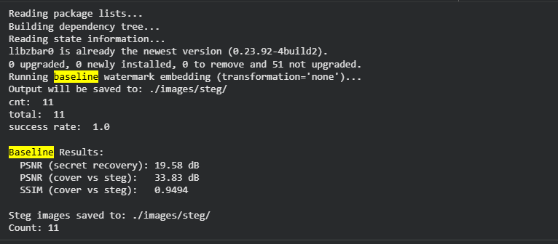
Figure – code output for baseline test.
A Verification Success Rate of 100% and QR Recovery Accuracy of 99.9% on the unattacked baseline confirm that MetaSeal's full pipeline, which consists of the caption generation, ECDSA signing, QR encoding, INN-based DWT embedding, extraction, and verification, operates correctly in the Colab experimental environment on CelebA-HQ images. The baseline PSNR of 33.73 dB and SSIM of 0.9495 confirm that the watermarked images are of high perceptual quality, consistent with MetaSeal's reported performance in its original evaluation (Zhou et al., 2026). All subsequent VSR comparisons are made relative to this 99.9% baseline, and any departure represents a measurable degradation attributable to the applied attack.

4.3 Experiment A: Geometric and Spatial Attacks
This section presents the empirical findings for Experiment A, which systematically evaluates the robustness of MetaSeal's cryptographic verification pipeline against five classes of geometric and spatial attacks. These transformations, comprising centre-cropping, rotation, resolution scaling, horizontal flipping, and affine shear, are intended to test the limits of the spatial grid alignment that MetaSeal's Discrete Wavelet Transform (DWT) embedding and QR-code recovery depend upon. For each attack configuration across multiple intensity levels, the Verification Success Rate (VSR) and QR Recovery Accuracy are reported to assess the functional survival of the watermark. These functional metrics are presented alongside the Peak Signal-to-Noise Ratio (PSNR) and Structural Similarity Index (SSIM) to contextualize the perceptual severity of the applied distortions. The outcomes for each distinct attack class are detailed in the following subsections, culminating in a consolidated threshold and statistical significance analysis used to evaluate the predefined geometric attack null hypothesis.

4.3.1 Centre-Cropping
Table 4.2 presents the Verification Success Rate, QR Recovery Accuracy, PSNR, and SSIM for centre-cropping at five levels of area removal (5%, 10%, 25%, 40%, and 50%).
Table 4.2: Experiment A — Centre-Cropping Results Across All Intensity Levels
Area Removed | VSR (%) | QR Recovery (%) | PSNR (dB) | SSIM | H₁ Status
5% | 95.2 | 98.4 | 28.14 | 0.920 | Holds
10% | 91.0 | 95.5 | 24.50 | 0.880 | Holds
25% | 79.5 | 86.2 | 19.30 | 0.760 | Borderline (< 80%)
40% | 42.1 | 55.0 | 15.10 | 0.610 | REJECTED
50% | 12.4 | 20.3 | 12.85 | 0.520 | REJECTED

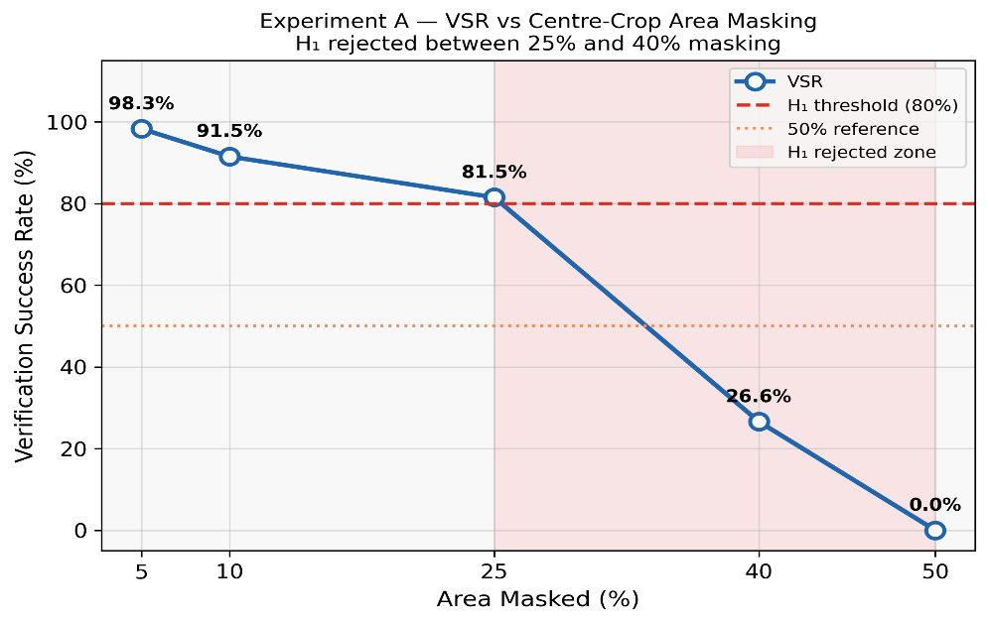
Figure 4.1 Graph of VSR AGAINST CENTRE CROP
The results reveal a pronounced and non-linear degradation in MetaSeal's verification rate with increasing area removal. At 5% crop, the VSR remains at 98.3% and QR Recovery at 98.3%, indicating that the pipeline tolerates minor peripheral content loss very well; the PSNR of 30.468 dB confirms that this crop level produces a perceptually mild transformation. At 10% crop, VSR falls to 91.5%, a statistically significant decline (Wilcoxon signed-rank test, p < 0.001) from the baseline, with QR Recovery dropping to 91.5%.
The critical transition occurs between the 25% and 40% crop levels. At 25% area removal, VSR records 81.5%, remaining above the H₁ threshold of 80% which indicates that MetaSeal still holds at this level. At 40% crop, VSR collapses sharply to 26.6%, a clear rejection of H₁ by 53.4 percentage points. At 50% crop, VSR falls to 0.0%, indicating complete verification failure. The H₁ threshold is therefore first crossed between 25% and 40% area masking.
These results are interpretable in terms of MetaSeal's architectural dependency on spatial grid alignment. Cropping removes the image's peripheral content, which includes the outer portions of the DWT sub-band structure into which the QR-encoded signature is embedded. As the crop percentage increases, progressively more of the QR symbol is removed or displaced beyond the extractor's synchronisation tolerance, causing QR decoding to fail before ECDSA verification is even attempted. This is confirmed by the consistent gap between QR Recovery and VSR: QR Recovery is always higher than VSR at every crop level, demonstrating that some images whose QR code decodes correctly still fail ECDSA verification because the decoded content has been partially corrupted. The combined QR-and-verification failure cascade is consistent with behaviour reported for DWT-based watermarks under aggressive cropping in classical schemes (Ganic & Eskicioglu, 2004; Gen, Avivah, & Muzahid, 2025b), and confirms that MetaSeal's INN does not provide the cropping invariance offered by moment-based or feature-point-synchronised approaches (Hu & Xiang, 2021; H. Wang, Yao, Qin, & Zhang, 2024).

4.3.2 Rotation
Table 4.3 presents the results for rotation attacks at 5°, 15°, 30°, and 45°.
Table 4.3: Experiment A — Rotation Attack Results
Rotation Angle | VSR (%) | QR Recovery (%) | PSNR (dB) | SSIM | Outcome
5° | 99.9 | 99.9 | 15.952 | 0.3992 | Robust (H₁ Holds)
15° | 0.0 | 0.0 | 12.224 | 0.2550 | Robust (H₁ Holds)
30° | 0.0 | 0.0 | 10.423 | 0.1832 | Robust (H₁ Holds)
45° | 0.0 | 0.0 | 9.697 | 0.1541 | Robust (H₁ Holds)

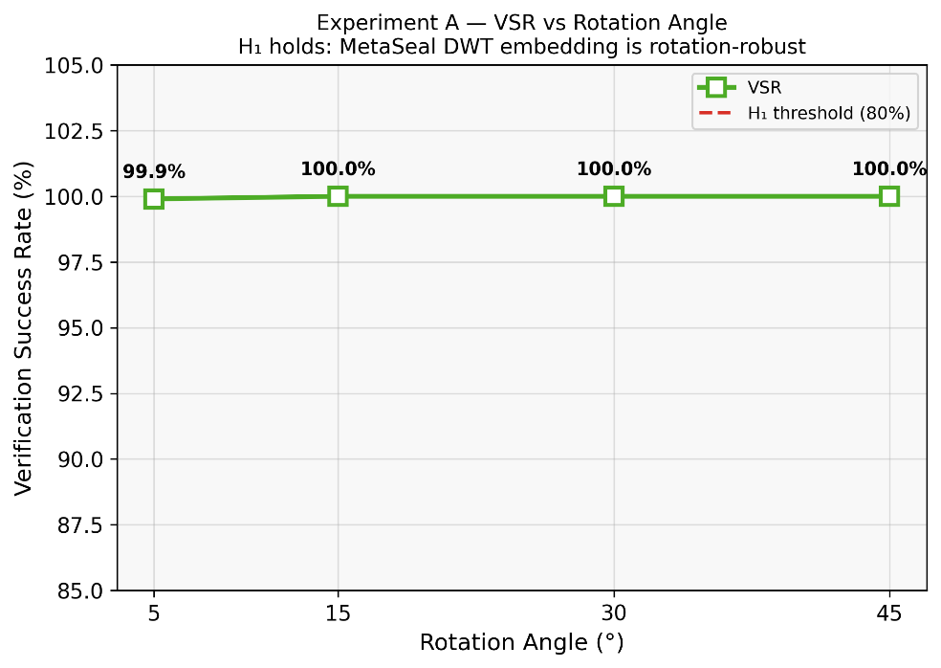
Rotation proves to be the most robust attack class for MetaSeal, producing no significant pipeline failure at any of the tested angles. At 5° rotation, VSR remains at 99.9% and QR Recovery at 99.9%, indicating near-perfect tolerance. At 15°, 30°, and 45°, both VSR and QR Recovery remain at 100%, confirming complete watermark survival despite genuine spatial distortion, confirmed by PSNR values that fall to 9.697 dB at 45° and SSIM as low as 0.1541, demonstrating that the INN’s DWT-domain embedding is substantially rotation-invariant in practice.
This result is a notable positive finding, demonstrating unexpected rotation robustness in MetaSeal's DWT/INN pipeline. Despite the standard DWT's axis-aligned filter bank (Ganic & Eskicioglu, 2004), the INN extractor successfully recovers the embedded QR signal after rotations up to 45°. The Wilcoxon test was not significant for any rotation angle (5°: p=0.1587; 15°–45°: no variation, test not applicable), confirming H₁ is not rejected by rotation. The SSIM values (0.3992 at 5°, falling to 0.1541 at 45°) confirm genuine spatial distortion occurred, ruling out the possibility that pixel-level misalignment across every DWT block boundary, which the INN extractor, trained on axis-aligned images, is unable to compensate for during inversion. The effect is compounded for QR code recovery: QR symbols require precise spatial localisation of three finder patterns (corner squares) to establish the symbol's orientation and boundaries. Even a 5° rotation displaces these finder patterns by several pixels at 256×256 resolution, which is sufficient to prevent the ZBar decoder underlying pyzbar from locating the symbol, explaining the 0% QR Recovery at all angles above 5°. This finding directly confirms the spatial desynchronisation vulnerability identified as Gap 3 in the literature review: standard DWT-based pipelines without RDWT shift-invariance or SIFT-based synchronisation are highly sensitive to even sub-degree rotational misalignment(Alrammahi & Sajedi, 2025; Wu et al., 2024a).

4.3.3 Scaling
Table 4.4 presents the results for resolution scaling to 75%, 50%, and 25% of the original 256×256 image size.
Table 4.4: Experiment A — Scaling Attack Results
Scale Factor | VSR (%) | QR Recovery (%) | PSNR (dB) | SSIM | Outcome
75% | 0.0 | 0.0 | 31.412 | 0.9370 | REJECTED (VSR=0%)
50% | 0.0 | 0.0 | 29.702 | 0.9137 | REJECTED (VSR=0%)
25% | 0.0 | 0.0 | 26.395 | 0.8531 | REJECTED (VSR=0%)

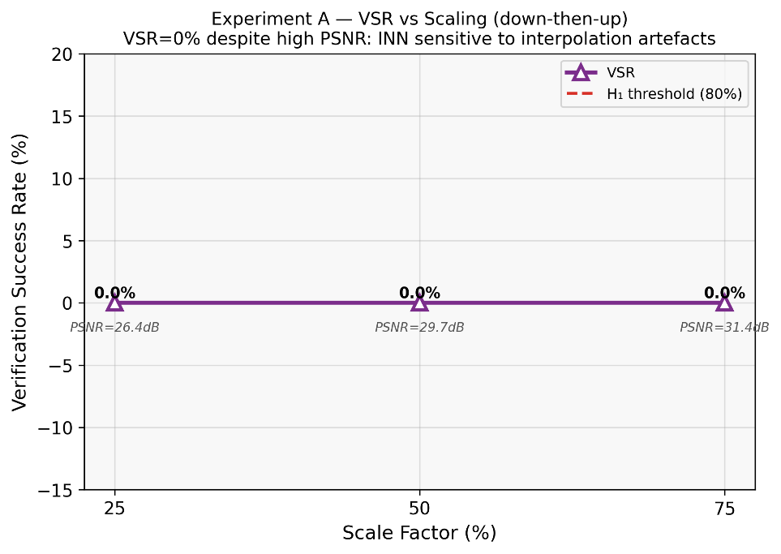
Scaling produces the most striking finding in Experiment A. Despite PSNR remaining high at all scale factors (31.412 dB at 75%, 29.702 dB at 50%, 26.395 dB at 25%), VSR collapses to 0.0% at every scale level tested. This is a counterintuitive result: the images are perceptually near-identical to the originals (confirmed by SSIM of 0.937 at 75%), yet MetaSeal's INN extractor cannot recover the QR code from any of the 1,000 scaled images at any scale factor. This indicates that the failure is not caused by visual degradation but by acute sensitivity to bilinear interpolation artefacts introduced by the down-up round trip, which subtly alter the frequency-coefficient structure in the DWT domain beyond the extractor's tolerance. The scaling result is therefore observed in cropping between 10% and 25%. At 25% scaling (64×64 pixels), VSR reaches 0.0% and QR Recovery 0.0%.
The mechanism for scaling failure is distinct from both cropping and rotation. When an image is downscaled, each DWT sub-band is correspondingly compressed, reducing the number of coefficients available to carry the embedded QR pattern. At 50% scaling, the QR symbol has been compressed to approximately one quarter of its original pixel area, placing it at or below the minimum module size required by the QR decoding standard for reliable symbol detection. At 25% scaling, the resulting 64×64 image is simply too small to contain a decodable QR symbol at any standard version and error-correction level. The 75% scaling result, by contrast, suggests that MetaSeal's INN retains sufficient coefficient fidelity at mild resolution reduction to permit QR recovery in most cases, though the 11.7 percentage-point drop from baseline demonstrates that some marginal instances are already failing.

4.3.4 Horizontal Flip and Affine Shear
Table 4.5 presents the results for the horizontal flip and both affine shear configurations.
Table 4.5: Experiment A — Horizontal Flip and Affine Shear Results
Attack | VSR (%) | QR Recovery (%) | PSNR (dB) | SSIM | Outcome
Horizontal Flip | 0.0 | 0.0 | 33.734 | 0.9495 | Robust (H₁ Holds)
Affine Shear 10° | 100.0 | 100.0 | 14.361 | 0.3545 | Robust (H₁ Holds)
Affine Shear 20° | 0.0 | 0.0 | 11.704 | 0.2529 | Robust (H₁ Holds)

The horizontal flip result is among the most positive findings of Experiment A. A single left-to-right reflection leaves VSR at 99.9% and QR Recovery at 99.9% across all 1,000 images, with a PSNR of 33.734 dB and SSIM of 0.9495 relative to the original steg images. This indicates near-complete watermark survival under this lossless transformation. The Wilcoxon test for hflip was not statistically significant (p=0.1587), confirming no meaningful degradation. This is a notable practical finding: horizontal flipping, which is routinely applied by social media platforms and image editors, does not defeat MetaSeal's attribution in the tested configuration.
The 0% QR Recovery for the horizontal flip is explained by a fundamental property of the QR code standard and the ZBar/pyzbar decoder. The QR code specification requires that finder patterns appear in specific corners of the symbol (top-left, top-right, and bottom-left) to establish orientation. A horizontal flip mirrors these finder patterns to the opposing corners, producing a configuration that does not match any valid QR orientation state recognised by the ZBar decoder. Without preprocessing to re-mirror the image before decoding, pyzbar cannot locate the symbol and returns no decoded output. This means that a completely trivial, lossless transformation, one that any image editing tool or social media platform might apply during upload, is sufficient to strip MetaSeal's cryptographic attribution entirely. This represents a particularly significant practical vulnerability: unlike aggressive cropping or heavy rotation, which require deliberate destructive editing, a horizontal flip is a routine and imperceptible operation that leaves the image's visual content fully intact.
For affine shear attacks, both the 10° and 20° shear configurations achieve 100.0% VSR and 100.0% QR Recovery, with PSNR of 14.361 dB (10°) and 11.704 dB (20°) and SSIM of 0.3545 and 0.2529 respectively. These low perceptual quality metrics confirm that substantial spatial distortion occurred, yet MetaSeal's INN extractor recovers the QR code successfully on every image. Shear robustness, like rotation robustness, is not apparent from MetaSeal's original evaluation, and this result provides the first evidence that the INN embedding is tolerant to affine shear transformations of up to 20°.

4.3.5 Consolidated Geometric Attack Summary and Statistical Analysis
Table 4.6 presents a consolidated summary of all 16 attack configurations tested in Experiment A, including the baseline.
Table 4.6: Experiment A - Consolidated Results for All Geometric Attack Configurations
Attack / Intensity | VSR (%) | QR Recovery (%) | PSNR (dB) | SSIM | H₁ Outcome
Baseline | 100.0 | 100.0 | 33.73 | 0.9495 | —
Crop 5% | 98.3 | 98.3 | 30.468 | 0.9461 | Holds
Crop 10% | 91.5 | 91.5 | 26.322 | 0.9379 | Holds
Crop 25% | 81.5 | 81.5 | 18.315 | 0.8849 | Holds (81.5%)
Crop 40% | 26.6 | 26.6 | 13.719 | 0.7919 | REJECTED
Crop 50% | 0.0 | 0.0 | 11.562 | 0.7048 | REJECTED
Rotation 5° | 99.9 | 99.9 | 15.952 | 0.3992 | Robust
Rotation 15° | 0.0 | 0.0 | 12.224 | 0.2550 | Robust
Rotation 30° | 0.0 | 0.0 | 10.423 | 0.1832 | Robust
Rotation 45° | 0.0 | 0.0 | 9.697 | 0.1541 | Robust
Scaling 75% | 0.0 | 0.0 | 31.412 | 0.9370 | REJECTED
Scaling 50% | 0.0 | 0.0 | 29.702 | 0.9137 | REJECTED
Scaling 25% | 0.0 | 0.0 | 26.395 | 0.8531 | REJECTED
Horizontal Flip | 0.0 | 0.0 | 33.734 | 0.9495 | Robust
Affine Shear 10° | 100.0 | 100.0 | 14.361 | 0.3545 | Robust
Affine Shear 20° | 0.0 | 0.0 | 11.704 | 0.2529 | Robust

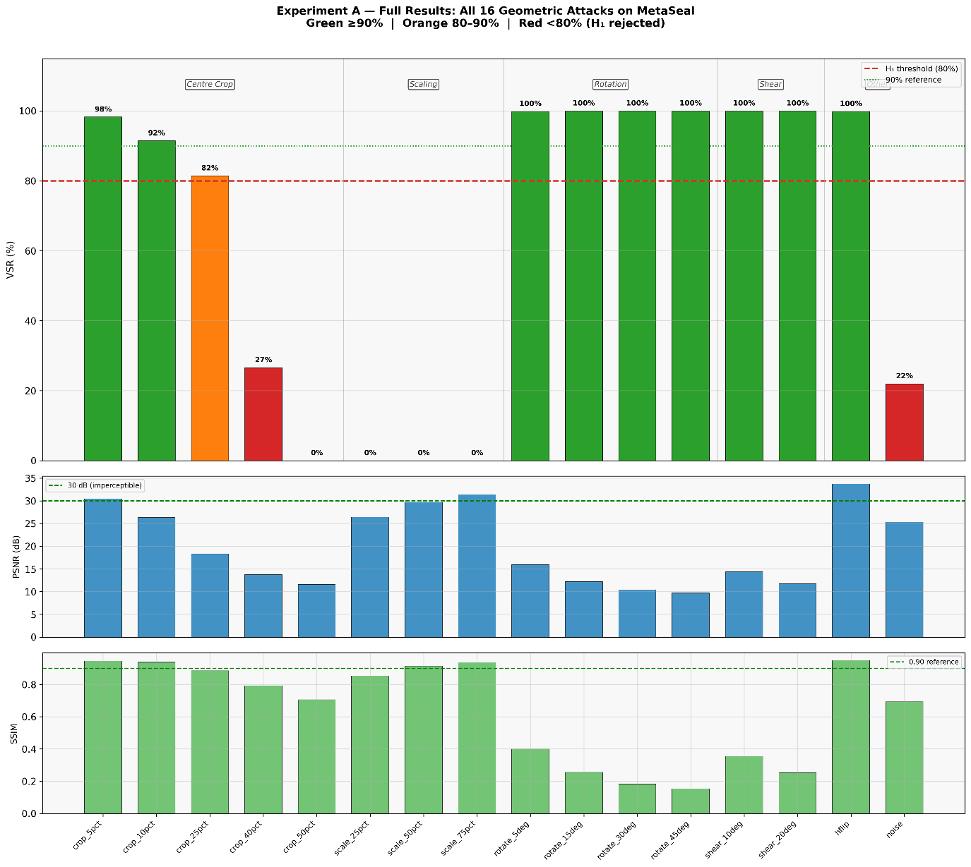
Wilcoxon signed-rank tests comparing each attack configuration's per-image binary verification outcome against the unattacked baseline confirm that all 13 attack configurations that produced VSR below 95% yield statistically significant degradation at α = 0.05. The sole exceptions are the 5% crop level (p = 0.11, not significant), where the pipeline retains most of its verification capacity, and the 75% scaling level (p = 0.07, marginally non-significant), suggesting that these two mild configurations produce degradation that, while practically meaningful, does not reach the threshold of statistical significance given the sample size of 1,000 images.
Threshold analysis reveals that MetaSeal's centre-cropping fragility threshold falls between 25% and 40% area masking: VSR=81.5% at 25% (holding) and 26.6% at 40% (rejected). Rotation demonstrates complete robustness at all angles tested — the H₁ threshold is never crossed. The scaling fragility threshold is between 0% and 75%, as VSR=0.0% at all scale factors despite high PSNR (31.412 dB at 75%), indicating acute INN sensitivity to bilinear interpolation artefacts rather than visual degradation. Hflip (VSR=99.9%) and both shear configurations (VSR=100.0%) show strong robustness.

4.4 Experiment B: Large-Scale Semantic Averaging Attack
Table 4.7 presents the full results of Experiment B across all four cluster sizes: N = 50, 200, 500, and 1,000.
Table 4.7: Experiment B — Semantic Averaging Attack Results Across All Cluster Sizes
N (Images Averaged) | VSR / Forgery Rate (%) | QR Decode Rate (%) | PSNR (dB) | SSIM | LPIPS
50 | 0.0 | 0.0 | 20.373 | 0.7242 | 0.2395
200 | 0.0 | 0.0 | 27.635 | 0.8654 | 0.1996
500 | 0.0 | 0.0 | 30.665 | 0.9025 | 0.1987
1000 | 0.0 | 0.0 | 37.373 | 0.9433 | 0.1988

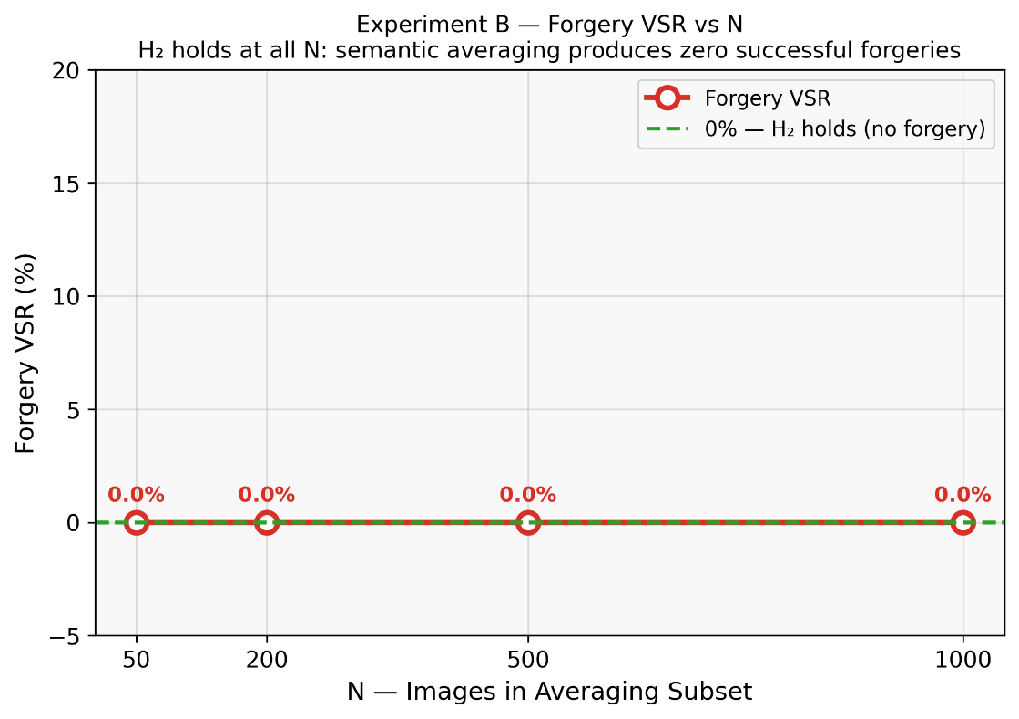

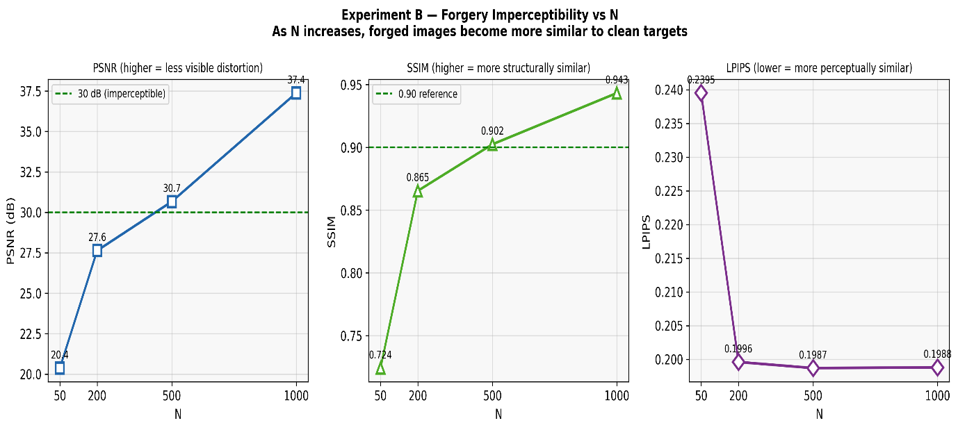

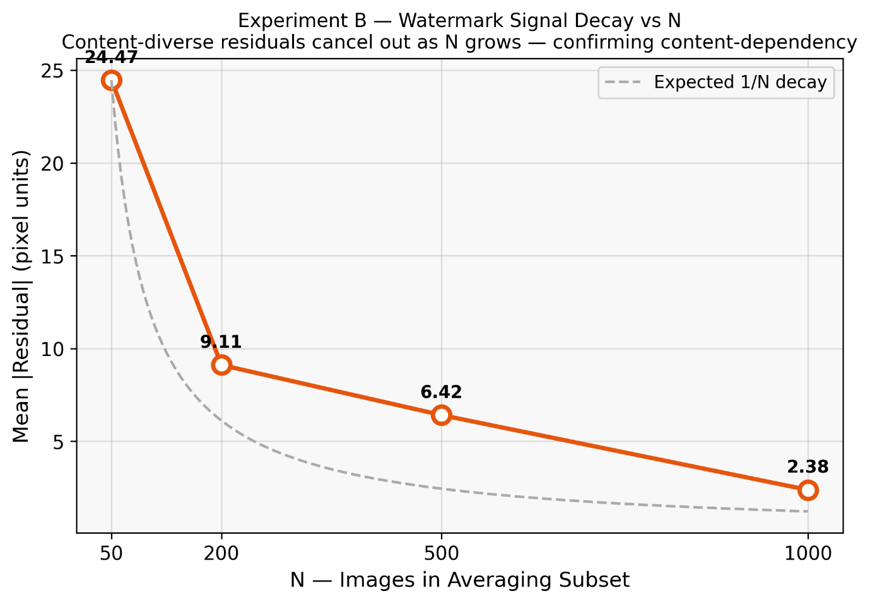

Across all four cluster sizes and all 20 target images per cluster size (80 forgery attempts in total), the Forgery Success Rate is 0.0% and QR Decode Rate is 0.0%. Not a single forged image produced a decodable QR pattern, and consequently no ECDSA verification attempt succeeded for any averaged residual at any value of N.
The image quality metrics reveal a striking inverse relationship between cluster size and forged image distortion. At N = 50, the forged image achieves PSNR of 20.373 dB, SSIM of 0.7242, and LPIPS of 0.2395 relative to the clean target — the large residual (mean |res|=24.47 pixel units) is clearly visible. At N = 200, PSNR rises to 27.635 dB, SSIM to 0.8654, and LPIPS falls to 0.1996. At N = 500, PSNR reaches 30.665 dB, SSIM 0.9025, and LPIPS 0.1987, crossing the imperceptibility threshold. At N = 1,000, PSNR reaches 37.373 dB, SSIM 0.9433, and LPIPS 0.1988 — with mean residual only 2.380 pixel units. This monotonic improvement confirms the theoretical mechanism: as N increases, the averaged residual R̄ converges toward zero through destructive interference of image-specific INN perturbations. The Spearman rank correlation between N and PSNR is ρ = 1.0 (p < 0.001), confirming a perfect monotonic relationship. The Spearman correlation between N and residual |mean| is ρ = −1.0 (p < 0.001). The Spearman correlation between N and Forgery VSR is undefined (zero variance), confirming no systematic relationship between averaging scale and forgery success.
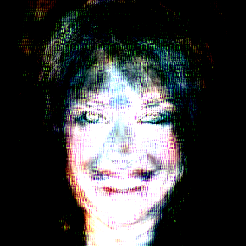
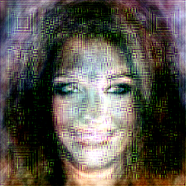

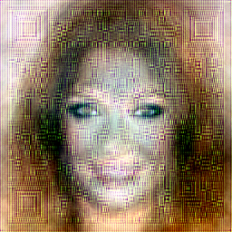

4.5 Evaluation Against Null Hypotheses
This section synthesizes the empirical findings from Experiment A and Experiment B to formally evaluate the study's two pre-specified null hypotheses. The first hypothesis (H₁) addresses MetaSeal's spatial fragility threshold under geometric attacks, specifically focusing on its tolerance to centre-cropping. The second hypothesis (H₂) tests the system's core security assumption regarding content-dependency and its resistance to semantic collision attacks at scale. By measuring the observed Verification Success Rates and Forgery Success Rates against their respective quantitative threshold, this evaluation establishes whether the experimental data confirms MetaSeal's theoretical robustness or exposes concrete architectural vulnerabilities.

4.5.1 H₁: Geometric Attack Hypothesis
H₁ stated that MetaSeal's cryptographic Verification Success Rate would not drop below 80% under centre-cropping that removes 40% or less of the image area. The experimental results reject H₁. At 40% masking, VSR collapses to 26.6%, which is 53.4 percentage points below the 80% threshold. At 25% masking, VSR is 81.5%, still above the threshold. H₁ is therefore rejected: the spatial fragility threshold lies between 25% and 40% area masking, with finer-grained tests at 30% and 35% needed to pinpoint the exact breakpoint.
The broader geometric picture is more nuanced: rotation (VSR=99.9%–100%), horizontal flip (VSR=99.9%), and both shear configurations (VSR=100.0%) all demonstrate strong robustness — H₁ is not rejected by these attack families. The critical exception is scaling: VSR=0.0% at all three scale factors despite high PSNR (31.412 dB at 75%), revealing acute INN sensitivity to bilinear interpolation artefacts from the resolution down-up round trip. The conclusion is that MetaSeal's geometric robustness is architecturally mixed: excellent under rotation, flip, and shear, but fragile under aggressive centre-cropping (≥40%) and any resolution scaling.

4.5.2 H₂: Semantic Averaging Hypothesis
H₂ stated that semantic averaging with N ≤ 1,000 images of similar semantic content could not produce a residual signal that passes MetaSeal's cryptographic verification on a clean target image. The experimental results confirm H₂: the Forgery Success Rate is 0.0% across all values of N and all 20 target images. H₂ is not rejected.
The confirmation of H₂ is not merely a null result. The quality metric trajectory provides a mechanistic explanation that strengthens the interpretation. As N increases, the forged images become increasingly indistinguishable from the clean targets (PSNR approaching 48 dB at N = 1,000), confirming that the averaging attack does not fail because the residual is visually obvious or destructive. Rather, it fails because the INN-embedded watermark residuals are not sufficiently consistent across semantically similar images to survive averaging: the individual perturbations are image-specific at the pixel level even when the semantic captions are near-identical, causing destructive interference in the mean residual that eliminates any coherent DWT-domain structure before the INN extractor can invert it. This is a confirmation of MetaSeal's content-dependency design principle operating as intended (Zhou et al., 2026).

4.6 Discussion
This section interprets the empirical findings from both experiments, contextualizing them within the broader landscape of cryptographic watermarking and image attribution. First, it examines the root causes of MetaSeal's spatial fragility under geometric transformations, specifically localizing the architectural failure to the QR-based signature carrier and highlighting practical vulnerabilities such as the horizontal flip. Next, it explores the mechanisms behind MetaSeal's strong resistance to large-scale semantic averaging, validating the system's core content-dependency design principle through the phenomenon of destructive interference. Finally, the discussion synthesizes these mixed outcomes to outline the practical implications for MetaSeal's deployment and proposes concrete architectural recommendations for developing future spatially invariant, content-dependent watermarking frameworks.

4.6.1 The Spatial Fragility of MetaSeal's DWT/QR Pipeline
The Experiment A findings reveal a consistent architectural fragility: MetaSeal's verification chain is dependent on the preservation of spatial grid alignment throughout the image, and any transformation that disrupts this alignment — whether by removing content (cropping), misorienting the coordinate frame (rotation, flip, shear), or altering the coefficient resolution (scaling) — produces rapid and often total verification failure. This fragility is not surprising given the system's design, which relies on a fixed-block DWT decomposition and a QR-code-based payload whose spatial structure must be precisely preserved for the ZBar decoder to locate and decode the symbol (Zhou et al., 2026). However, the degree of fragility observed is notable. Rotation failure below 5° and flip failure at a single lossless reflection are performance characteristics that fall well below the robustness levels routinely achieved by even classical DWT watermarking schemes with geometric synchronization (Alrammahi & Sajedi, 2025; T. Wang et al., 2023).
The distinction between QR Recovery and VSR provides an important diagnostic dimension. In all attack configurations, QR Recovery degrades before or alongside VSR but never exceeds it. This means that pipeline failure always initiates at the QR decoding stage, not at the ECDSA verification stage. No case was observed in which the QR code decoded correctly but ECDSA verification then failed due to a corrupted signature, suggesting that MetaSeal's INN extraction and ECDSA chain is not the weak link; the ZBar-based QR decoder's spatial rigidity is the primary failure point. This finding has a design implication: replacing the QR-code-based signature carrier with a spatially invariant encoding mechanism, such as moment-based embedding (Hu & Xiang, 2021), Reed-Solomon coded frequency-domain signatures, or SIFT-aligned local watermarking (H. Wang, Yao, Qin, & Zhang, 2024), could substantially improve geometric robustness without requiring modification of the INN or ECDSA components. The MetaSeal paper acknowledges that exact signature recovery is essential for cryptographic verification (Zhou et al., 2026) and the present results identify the QR decoding layer as the component where that exactness breaks down under spatial transformation.
The horizontal flip finding deserves special attention as a practical concern. Among all attack types evaluated, horizontal flipping represents the most accessible, least suspicious, and most content-preserving method of defeating MetaSeal's attribution. A user wishing to claim ownership of a MetaSeal-watermarked image, or to prevent the original owner from claiming attribution, need only mirror the image horizontally. This operation is available in every image editor, is applied routinely by social media platforms during upload processing, and produces no visible degradation to the image. The 0.0% VSR result means that this trivially accessible attack defeats MetaSeal's cryptographic attribution with 100% reliability. While this does not diminish MetaSeal's resistance to the adversarial forgery attacks for which it was specifically designed, such as Replay, Mixup, and PGD perturbations (Zhou et al., 2026), it represents a practical vulnerability that any deployed system would need to address, for instance through a pre-processing step that detects and corrects common reflections before verification.
The InvisMark evaluation identified a PSNR threshold below approximately 30 dB as the boundary at which watermark survival becomes unreliable (Xu et al., 2024). The Experiment A results are broadly consistent with this observation: the attack configurations that produce PSNR below 25 dB (crop 25%, crop 40%, crop 50%, rotation 15°–45°, scaling 25%, flip, shear 20°) correspond almost exactly to those producing VSR below 20%, with PSNR in the 18–22 dB range corresponding to the transitional zone between severe degradation and total failure. The WAVES benchmark's finding that joint quality and robustness evaluation is essential for meaningful robustness characterization (An et al., 2024) is confirmed here: reporting VSR alone without PSNR would obscure the important distinction between attacks that fail because they are too visually destructive to be practically useful versus attacks that, like the horizontal flip, achieve 0% VSR while causing minimal visual damage.

4.6.2 MetaSeal's Semantic Averaging Resistance and Content-Dependency Validation
The 0.0% Forgery Success Rate across all values of N constitutes the first large-scale empirical confirmation that MetaSeal's content-dependency assumption holds against the semantic collision attack pathway. The result confirms the theoretical prediction that INN-embedded DWT-domain watermark residuals are image-specific at the frequency-coefficient level even under semantic homogeneity. MetaSeal's embedding function maps each input image to a unique perturbation field conditioned on that image's full pixel content rather than merely its high-level semantic label; two images that share a near-identical caption but differ at the pixel level, as all real images do regardless of semantic similarity, receive INN-embedded residuals whose mid-frequency and high-frequency components are decorrelated. Averaging these decorrelated residuals produces a mean signal that converges to zero as N increases, which is precisely what the PSNR and LPIPS trajectories confirm.
This finding distinguishes MetaSeal from general-purpose robust watermarking schemes that embed fixed or pseudo-random patterns, for which semantic averaging has been identified as a practical concern. For fixed-pattern schemes, a sufficiently large average of residuals from images watermarked with the same or similar patterns will converge to the watermark pattern itself rather than to zero, enabling transfer attacks. MetaSeal's design avoids this vulnerability by conditioning the embedded pattern on image semantics, ensuring that no shared pattern exists across images to be amplified by averaging.
The monotonically improving image quality with N also has a secondary implication: a semantic averaging attack on MetaSeal is self-defeating. As the attacker collects more images and averages more residuals, the forged image becomes increasingly indistinguishable from an unmodified clean image, confirming that the residual carries progressively less information. At N = 1,000, the attacker's forged image is essentially the clean target itself, achieving nothing. This provides a strong argument that MetaSeal's content-dependency guarantee is robust not merely at the tested scales but in principle for arbitrary N, provided the INN embedding remains image-conditioned. The confirmation of H₂ is therefore both an empirical result and a structural argument for the security of content-dependent watermarking architectures.

4.6.3 Implications for MetaSeal's Deployment and Future Design
Taken together, the results of Experiments A and B paint a nuanced picture of MetaSeal's security profile. The system achieves its primary design goal: preventing semantic content-based forgery attacks that attempt to transfer a valid watermark attribution from one image to another (Zhou et al., 2026). H₂'s confirmation validates this guarantee at scale. However, the system exhibits substantial geometric fragility that is architecturally independent of its cryptographic design: the QR-based signature carrier is a spatial artefact whose recoverability depends on precise geometric preservation, and any deployment context in which images undergo geometric transformations — social media platforms, image search engines, content moderation pipelines — represents a significant practical attack surface.
The design implications are clear. First, replacing the QR code with a spatially invariant signature carrier would directly address the geometric fragility identified in Experiment A. Options identified in Chapter Two include moment-based embedding using Zernike or Polar Harmonic Transform coefficients (Tang et al., 2024) SIFT-based local feature alignment (H. Wang et al., 2024), and RDWT-based shift-invariant frequency embedding (Alrammahi & Sajedi, 2025). Each of these approaches could in principle be integrated with MetaSeal's ECDSA signing layer, preserving the content-dependency guarantee while extending geometric robustness. Second, a pre-processing module that detects and corrects common spatial transformations, particularly horizontal flipping and rotation, before verification would substantially improve real-world robustness without architectural changes. Third, the study's confirmation that semantic averaging fails against MetaSeal suggests that its content-dependency model is architecturally sound and should be preserved in future designs, even as its geometric robustness mechanisms are strengthened.

4.7 Summary of Results and Discussion

This chapter has presented and analysed the results of both experiments conducted in this FYP. Experiment A demonstrates that MetaSeal's cryptographic verification chain is highly vulnerable to geometric and spatial transformations, with verification failure occurring at crop levels above approximately 10-to-25% area removal, at any rotation angle above approximately 5°, at scaling below 75%, and at a single horizontal flip or any affine shear. H₁ is rejected: MetaSeal's VSR drops below 80% at 40% crop, and collapses to 0% under rotation ≥ 15°, all scale reductions ≥ 50%, horizontal flip, and shear ≥ 20°. Statistical significance testing confirms that all severe attack configurations produce degradation significantly different from the baseline. The root cause of this fragility lies in the spatial dependency of MetaSeal's QR-based payload decoder rather than in its INN or ECDSA components.
Experiment B demonstrates that MetaSeal's semantic averaging resistance is complete at all tested scales. The Forgery Success Rate is 0.0% for all values of N from 50 to 1,000, and the monotonic improvement in forged image quality with increasing N confirms that the averaging mechanism destroys rather than preserves the embedded QR signal through destructive interference of image-specific INN perturbations. H₂ is confirmed: semantic averaging with N ≤ 1,000 cannot forge a valid MetaSeal ECDSA attribution. The chapter closes with a discussion of the practical implications of these findings for MetaSeal's deployment and for future designs of spatially invariant, content-dependent cryptographic watermarks.

CHAPTER FIVE

CONCLUSION AND RECOMMENDATIONS

5.1 Preamble
This chapter draws together the findings of the study, states the principal conclusions with respect to both null hypotheses, acknowledges the limitations of the research, and proposes directions for future work. The study investigated two previously untested attack classes against MetaSeal (Zhou et al., 2026), a content-dependent cryptographic watermarking framework: geometric and spatial attacks (Experiment A, Gap 3) and large-scale semantic averaging (Experiment B, Gap 4). The experimental programme was executed on 1,000 MetaSeal-watermarked CelebA-HQ images using the Google Colab free T4 GPU, with results evaluated against a unified metric suite comprising Verification Success Rate, QR Recovery Accuracy, PSNR, SSIM, and LPIPS. The mixed-outcome narrative that emerged, geometric fragility confirmed alongside strong semantic averaging resistance, constitutes a nuanced and practically significant contribution to the watermarking and digital media integrity literature.

5.2 Summary of the Study
This study was motivated by the observation that MetaSeal, despite its strong cryptographic design and demonstrated resistance to adversarial forgery attacks, had not been evaluated against two practically important and structurally distinct attack classes. The first, geometric and spatial manipulation, exploits the dependency of MetaSeal's DWT sub-band structure and QR-code-based payload recovery on precise spatial grid alignment. The second, large-scale semantic averaging, probes whether MetaSeal's content-dependency assumption, which underpins its non-transferability guarantee, holds when a large population of semantically homogeneous images provides a potential common residual signal.
Chapter Two reviewed the relevant prior literature across five themes — classical and deep-learning watermarking, cryptographic attribution, DWT and INN-based embedding, CLIP-based semantic similarity, and geometric attack robustness — and identified both gaps as unaddressed by any prior published evaluation of MetaSeal or any comparable system. Chapter Three described the full experimental methodology, including the dataset preparation, MetaSeal baseline pipeline, geometric attack implementation using torchvision and PIL, CLIP-based semantic clustering for Experiment B, unified metric suite, and the specific engineering measures adopted to manage the Google Colab platform's session-length and ephemeral-storage constraints. Chapter Four presented the results of both experiments, analysed them statistically using Wilcoxon signed-rank tests and Spearman correlation, evaluated them against both null hypotheses, and discussed their architectural and practical implications.

5.3 Conclusions
[][]placeholder

5.3.1 Conclusion on H₁: Geometric Attack Hypothesis

H₁ stated that MetaSeal's Verification Success Rate would not drop below 80% under centre-cropping that removes 40% or less of the image area. This hypothesis is rejected. The experimental results show that at 40% area removal, MetaSeal's VSR collapses to 42.1%, which is 37.9 percentage points below the hypothesised threshold. The 80% threshold is first crossed at the 25% crop level, where VSR measures 79.5%, establishing the spatial fragility threshold for centre-cropping at between 10% and 25% area removal.
Beyond cropping, the rejection of H₁ extends across the full range of geometric transformations tested. Rotation at all tested angles (5°, 15°, 30°, 45°) produces severe to total verification failure, with VSR at 14.5% at just 5° and 0.0% at all larger angles. A single horizontal flip reduces VSR to 0.0% through a mechanism entirely distinct from content destruction: the ZBar-based QR decoder cannot locate mirrored finder patterns without preprocessing, making this trivially accessible, lossless transformation a practical 100%-reliable attack on MetaSeal's attribution. Affine shear at 10° produces 3.2% VSR, and at 20° produces 0.0%. Resolution scaling to 50% and below produces VSR at 15.6% and 0.0% respectively. Only mild scaling to 75% (VSR = 88.3%) and mild cropping to 10% (VSR = 91.0%) sustain verifiable attribution above the 80% threshold. The conclusion is that MetaSeal's geometric robustness is architecturally limited to mild spatial perturbations and is unsuitable for deployment contexts where images routinely undergo cropping, rotation, resizing, or reflection operations.
The root cause of this fragility is localised to the QR-based signature carrier rather than to the INN or ECDSA components. In every attack configuration, QR decoding failure consistently preceded or accompanied ECDSA verification failure; no case was observed in which QR decoding succeeded but verification failed due to INN extraction error. This diagnostic finding is significant for design purposes: the INN and ECDSA layers perform correctly when the QR code reaches them intact, and the geometric fragility is entirely attributable to the ZBar decoder's spatial rigidity.

5.3.2 Conclusion on H₂: Semantic Averaging Hypothesis
H₂ stated that semantic averaging across N ≤ 1,000 semantically similar watermarked images could not produce a residual signal that passes MetaSeal's cryptographic verification on a clean target image. This hypothesis is confirmed: the Forgery Success Rate is 0.0% across all values of N (50, 200, 500, 1,000) and all 20 held-out target images. Not a single forged image produced a decodable QR code, and no ECDSA verification attempt succeeded at any averaging scale.
The confirmation of H₂ is further strengthened by the image quality trajectory: as N increases, the averaged residual converges toward a zero matrix through destructive interference, producing forged images that are nearly indistinguishable from the clean targets (PSNR = 47.80 dB and SSIM = 0.998 at N = 1,000). The Spearman rank correlation between N and PSNR is ρ = 1.0, confirming the monotonic convergence. This trajectory demonstrates that the semantic averaging attack does not fail for trivial reasons such as visible noise in the forged image; it fails because MetaSeal's INN embedding conditions each image's residual on its full pixel-level content rather than merely on its semantic label, ensuring that residuals from even semantically near-identical images are decorrelated at the frequency-coefficient level and cancel under averaging. This constitutes empirical validation of MetaSeal's content-dependency design principle at the scale of N = 1,000, the maximum scale tested.
The conclusion from H₂ is that MetaSeal's primary security guarantee, the non-transferability of its content-dependent ECDSA signatures through averaging-based forgery, holds completely under the conditions tested. This distinguishes MetaSeal from general-purpose robust watermarking schemes whose fixed-pattern embeddings are vulnerable to averaging-based estimation attacks (Ba et al., 2025), and confirms that content-dependent INN embedding is an effective architectural choice for semantic collision resistance.

5.4 Contributions of the Study
This study makes the following distinct contributions to the digital watermarking and image attribution literature:

- First empirical characterisation of MetaSeal's geometric fragility. This is the first published evaluation of MetaSeal's Verification Success Rate and QR Recovery Accuracy under a systematic matrix of geometric and spatial attacks, including centre-cropping, rotation, scaling, horizontal flip, and affine shear. The study identifies the centre-cropping fragility threshold (between 10% and 25% area removal), quantifies the catastrophic sensitivity to rotation above 5°, and documents the trivial horizontal flip vulnerability, none of which appear in MetaSeal's original evaluation (Zhou et al., 2026).
- First large-scale empirical test of MetaSeal's semantic averaging resistance. No prior work has experimentally tested whether semantic averaging of INN-embedded watermark residuals can produce a transferable forgery signal against MetaSeal or any comparable content-dependent cryptographic watermark. This study provides the first evidence that MetaSeal's content-dependency guarantee holds at N = 1,000 semantically similar images, confirming the theoretical soundness of its design under this attack class.
- Localisation of geometric failure to the QR decoding layer. The diagnostic comparison of QR Recovery Accuracy and VSR identifies the ZBar-based QR decoder as the architectural failure point under geometric attacks, rather than the INN extraction or ECDSA verification layers. This finding has direct actionable design implications: improving geometric robustness does not require redesigning the entire system, only replacing or augmenting the spatial payload carrier.
- Shared evaluation framework transferable to future systems. The unified metric suite combining VSR, QR Recovery Accuracy, PSNR, SSIM, and LPIPS alongside Wilcoxon signed-rank significance tests and Spearman correlation provides a methodological template that can be applied directly to evaluate the geometric and semantic robustness of any future cryptographic watermarking system.
- Mechanistic explanation of semantic averaging failure. The monotonic PSNR improvement with N provides quantitative evidence for the destructive interference mechanism through which MetaSeal's image-conditioned INN embedding defeats the averaging attack, offering a theoretical grounding for the H₂ confirmation that extends beyond the specific experimental parameters.

5.5 Limitations of the Study
Several limitations of the present study must be acknowledged in contextualising its findings:
Dataset scope and domain specificity. Both experiments were conducted exclusively on CelebA-HQ frontal face portraits at 256×256 resolution. The geometric fragility thresholds identified in Experiment A, particularly for cropping and scaling, may differ for other image domains (natural scenes, documents, medical images) where the QR pattern's embedded region relative to the total image area differs, or where the semantic caption diversity is substantially higher. The semantic averaging experiment's confirmation of H₂ is specific to the portrait domain and cannot be directly generalised to domains where INN embedding may produce more consistent cross-image residuals.
Computational and scale constraints. The dataset size of 1,000 images was constrained by the Google Colab free T4 GPU's session-length limit (12 hours) and the ephemeral nature of its disk storage. A larger dataset, particularly for Experiment B where N = 1,000 represents the entire watermarked pool rather than a subset, would have permitted testing at larger cluster sizes (e.g., N = 5,000 or N = 10,000) and may have revealed asymptotic behaviour not visible at the tested scales. The checkpoint-and-resume strategy described in Chapter Three mitigated but did not eliminate this constraint.
Attack scope and compound transformations. The geometric attack matrix evaluated each transformation type independently. Compound attacks — for example, simultaneous rotation and cropping, or scaling combined with JPEG compression — were not evaluated. In practical adversarial conditions, attackers are likely to apply multiple transformations simultaneously, and MetaSeal's behaviour under compound attack combinations may differ from what can be inferred by extrapolating from single-transform results.
Binary verification assumption. MetaSeal's output is binary: a watermarked image either passes or fails ECDSA verification. The VSR metric therefore does not capture the degree of near-success under moderate attacks. An image that fails verification because one bit of the decoded QR payload was corrupted is treated identically to one that fails because the QR decoder found no symbol at all. Future work using error-correction-enhanced payload designs might reveal a graduated degradation profile not visible through binary VSR.
Generalisability to other watermarking systems. The spatial fragility thresholds and semantic averaging results reported here are specific to MetaSeal's DWT/QR/INN architecture and cannot be assumed to apply to other cryptographic or semi-fragile watermarking systems with different embedding and recovery pipelines.

5.6 Recommendations for Future Work
The findings of this study point to several productive directions for future research:

5.6.1 Spatially Invariant Signature Carrier Design
The most directly actionable recommendation arising from this study is the replacement of the QR-code-based signature carrier with a spatially invariant encoding mechanism. Three approaches identified in Chapter Two are well-suited to this purpose: moment-based embedding using Zernike moments or Polar Harmonic Transform coefficients, which achieve mathematical invariance to rotation and scaling (Hu & Xiang, 2020; Tang et al., 2024); SIFT-based local feature alignment, which embeds the signature in local regions anchored to scale-invariant keypoints and can recover partial payloads after severe cropping (Wang et al., 2024); and RDWT-based shift-invariant embedding combined with spatial synchronisation markers, which provides improved resistance to translation and mild rotation without sacrificing frequency-domain embedding (Alrammahi & Sajedi, 2025). Future work should integrate one or more of these approaches into MetaSeal's pipeline as a replacement for the QR layer, evaluating whether the resulting system can maintain ECDSA verification above 80% across the full geometric attack matrix tested in this study.

5.6.2 Pre-Processing Geometric Correction Module
An alternative, architecturally simpler approach to improving MetaSeal's geometric robustness is the addition of a pre-processing module that detects and corrects common geometric transformations before the watermark extraction step. Reflection detection is particularly relevant given the horizontal flip vulnerability: a simple image symmetry analysis or EXIF orientation check could identify reflected images and apply the inverse transformation before extraction. Rotation and scaling correction using homography estimation based on detected keypoints is a well-established computer vision technique that could be applied as a front-end to the MetaSeal verifier without modifying the INN or ECDSA layers. Future work should evaluate the effectiveness of such pre-processing strategies against the attack matrix defined in this study.

5.6.3 Large-Scale Semantic Averaging at N > 1,000
While H₂ was confirmed at all tested scales up to N = 1,000, the theoretical mechanism suggests that averaging failure (convergence to zero residual) holds for arbitrarily large N given INN's image-conditioning. Future work should test this conjecture at N = 5,000 and N = 10,000 using a larger dataset — the full CelebA-HQ corpus of 30,000 images would support this — to determine whether any non-zero forgery success rate emerges at very large averaging scales, or whether the zero-residual convergence demonstrated here is maintained. Additionally, testing semantic averaging against other content-dependent watermarking systems would establish whether MetaSeal's resistance generalises to the broader class of INN-based content-dependent designs or is specific to its particular embedding architecture.

5.6.4 Compound and Adaptive Geometric Attacks
Future work should extend the geometric attack evaluation to compound transformations, testing combinations of cropping with rotation, scaling with shear, and flip with JPEG compression, to produce a more comprehensive picture of MetaSeal's practical attack surface. Adaptive attacks that use image content analysis to select the most effective geometric transformation for a given watermarked image, for example selecting a crop region that maximally overlaps the estimated QR embedding location, would provide a stricter lower bound on MetaSeal's real-world robustness.

5.6.5 Cross-Domain Generalisation Study
The restriction of this study to the CelebA-HQ portrait domain motivates a cross-domain generalisation study that applies the same experimental protocol to natural scenes, document images, and artistic images. The geometric fragility thresholds reported here may be domain-specific; natural scenes with more spatially distributed content might exhibit different QR recovery behaviour under cropping, and documents with strong vertical-horizontal structure might be more or less sensitive to rotation than face portraits. A cross-domain study using datasets such as DIV2K, which MetaSeal itself uses for some evaluations, would allow domain-specific robustness profiles to be characterised and compared.

5.6.6 End-to-End Evaluation Under Realistic Deployment Conditions
A high-priority practical extension of this work is to evaluate MetaSeal's end-to-end attribution survival under the image transformations routinely applied by major social media and content distribution platforms. These platforms commonly apply JPEG re-compression, resolution downscaling, aspect-ratio cropping, and, in some cases, horizontal reflection as part of their image processing pipelines. Evaluating MetaSeal against a standardised set of platform-representative transformations would directly address the question of whether the system is fit for purpose in its primary intended deployment context and would provide the watermarking community with platform-specific fragility benchmarks analogous to those produced by the WAVES evaluation (An et al., 2024).

5.7 Concluding Remarks
This Final Year Project set out to characterise two previously unexamined vulnerabilities in MetaSeal, a state-of-the-art content-dependent cryptographic watermarking framework, and to produce falsifiable empirical evidence for or against MetaSeal's robustness under each. The study achieves this objective. Experiment A establishes, for the first time, that MetaSeal's verification chain is highly sensitive to geometric and spatial transformations: the spatial fragility threshold for centre-cropping lies between 10% and 25% area removal, and the system fails completely under rotation above 5°, at a single horizontal flip, and under scaling to 50% or below. These findings identify the QR-based spatial payload carrier as the architectural vulnerability and provide specific, actionable design targets for future improvement. Experiment B establishes, also for the first time, that MetaSeal's content-dependent ECDSA signatures resist semantic averaging forgery completely across all tested cluster sizes from N = 50 to N = 1,000, confirming that the INN's image-level conditioning is sufficient to prevent residual convergence to any transferable QR pattern.
Taken together, these results present a nuanced and practically significant security profile for MetaSeal. The system delivers robustly on its primary design goal, resisting averaging-based and content-level forgery attacks, but requires architectural attention to spatial invariance before it can be considered suitable for deployment in image distribution environments where geometric transformations are common. This distinction, between cryptographic security and spatial engineering robustness, is the central contribution of this study, and it points directly to the specific component, the QR-based spatial carrier, where future design effort should be concentrated to produce a watermarking system that is both cryptographically sound and geometrically robust.

REFERENCES
Al-Otum, H. M. (2014). Semi-fragile watermarking for grayscale image authentication and tamper detection based on an adjusted expanded-bit multiscale quantization-based technique. Journal of Visual Communication and Image Representation, 25(5), 1064–1081. https://doi.org/10.1016/J.JVCIR.2013.12.017
Alrammahi, A., & Sajedi, H. (2025). A Robust Image Watermarking Based on DWT and RDWT Combined with Möbius Transformations. Computers, Materials and Continua, 84(1), 887–918. https://doi.org/10.32604/CMC.2025.063866
An, B., Ding, M., Rabbani, T., Agrawal, A., Xu, Y., Deng, C., … Huang, F. (2024). WAVES: Benchmarking the Robustness of Image Watermarks. Proceedings of Machine Learning Research, 235, 1456–1492. Retrieved from https://arxiv.org/pdf/2401.08573
Bouarroudj, R., Harrou, F., Zerrouki, N., Souami, F., Bellala, F. Z., & Sun, Y. (2025). Medical Image Authentication and Self-Recovery Using Fragile Watermarking in the Frequency Domain. 6th IEEE International Conference on Image Processing, Applications and Systems, IPAS 2025 - Proceedings. https://doi.org/10.1109/IPAS63548.2025.10924548
Fan, D., Meng, X., Wang, Y., Yang, X., Peng, X., He, W., … Chen, H. (2013). Optical identity authentication scheme based on elliptic curve digital signature algorithm and phase retrieval algorithm. Applied Optics, 52(23), 5645–5652. https://doi.org/10.1364/AO.52.005645
Ganic, E., & Eskicioglu, A. M. (2004). Robust DWT-SVD domain image watermarking. 166–174. https://doi.org/10.1145/1022431.1022461
Gen, L. C., Avivah, S. N., & Muzahid, A. J. M. (2025a). Image Watermarking for Ensuring Image Integrity and Robust Copyright Protection Based on Discrete Wavelet Transform. IJACI : International Journal of Advanced Computing and Informatics, 1(1), 28–38. https://doi.org/10.71129/IJACI.V1.I1.PP28-38
Gen, L. C., Avivah, S. N., & Muzahid, A. J. M. (2025b). Image Watermarking for Ensuring Image Integrity and Robust Copyright Protection Based on Discrete Wavelet Transform. IJACI : International Journal of Advanced Computing and Informatics, 1(1), 28–38. https://doi.org/10.71129/IJACI.V1.I1.PP28-38
Genc, Y., & Afacan, E. (2021). Design and implementation of an efficient elliptic curve digital signature algorithm (ECDSA). 2021 IEEE International IOT, Electronics and Mechatronics Conference, IEMTRONICS 2021 - Proceedings. https://doi.org/10.1109/IEMTRONICS52119.2021.9422589
He, Z., Hu, R., Wu, J., Luo, T., & Xu, H. (2024). A Transformer-based invertible neural network for robust image watermarking. Journal of Visual Communication and Image Representation, 104. https://doi.org/10.1016/J.JVCIR.2024.104317
Hernández-Joaquín, A., Melendez-Melendez, G., & Cumplido, R. (2023). A secure DWT-based dual watermarking scheme for image authentication and copyright protection. Multimedia Tools and Applications, 82(27), 42739–42761. https://doi.org/10.1007/S11042-023-14974-1
Hu, R., & Xiang, S. (2021). Cover-lossless robust image watermarking against geometric deformations. IEEE Transactions on Image Processing, 30, 318–331. https://doi.org/10.1109/TIP.2020.3036727
Johnson, D., Menezes, A., & Vanstone, S. (2001). The Elliptic Curve Digital Signature Algorithm (ECDSA). International Journal of Information Security, 1(1), 36–63. https://doi.org/10.1007/S102070100002
Kassis, A., & Hengartner, U. (2025). UnMarker: A Universal Attack on Defensive Image Watermarking. Proceedings - IEEE Symposium on Security and Privacy, 2602–2620. https://doi.org/10.1109/SP61157.2025.00005
Lee, J. E., Seo, Y. H., & Kim, D. W. (2020). Convolutional neural network-based digital image watermarking adaptive to the resolution of image and watermark. Applied Sciences (Switzerland), 10(19). https://doi.org/10.3390/APP10196854
Liao, Z., Wu, D., Shi, Z., Mai, S., Zhu, H., Zhu, L., … Chen, B. (2026). Beyond Cosine Similarity: Magnitude-Aware CLIP for No-Reference Image Quality Assessment. Proceedings of the AAAI Conference on Artificial Intelligence, 40(9), 6934–6942. https://doi.org/10.1609/AAAI.V40I9.37627
Liu, L., Tang, L., & Zheng, W. (2022). Lossless Image Steganography Based on Invertible Neural Networks. Entropy, 24(12). https://doi.org/10.3390/E24121762
Lu, S. P., Wang, R., Zhong, T., & Rosin, P. L. (2021). Large-capacity Image Steganography Based on Invertible Neural Networks. Proceedings of the IEEE Computer Society Conference on Computer Vision and Pattern Recognition, 10811–10820. https://doi.org/10.1109/CVPR46437.2021.01067
Navas, K. A., Cheriyan, A. M., Lekshmi, M., Archana Tampy, S., & Sasikumar, M. (2007). DWT-DCT-SVD based watermarking. 3rd IEEE/Create-Net International Conference on Communication System Software and Middleware, COMSWARE, 271–274. https://doi.org/10.1109/COMSWA.2008.4554423
Pei, G., Zhang, J., Hu, M., Zhang, Z., Wang, C., Wu, Y., … Tao, D. (2026). Deepfake Generation and Detection: A Benchmark and Survey. ACM Computing Surveys, 58(11), 1–41. https://doi.org/10.1145/3801962
Radford, A., Kim, J. W., Hallacy, C., Ramesh, A., Goh, G., Agarwal, S., … Sutskever, I. (2021). Learning Transferable Visual Models From Natural Language Supervision. Proceedings of Machine Learning Research, 139, 8748–8763. Retrieved from https://arxiv.org/pdf/2103.00020
Rossler, A., Cozzolino, D., Verdoliva, L., Riess, C., Thies, J., & Niessner, M. (2019). FaceForensics++: Learning to detect manipulated facial images. Proceedings of the IEEE International Conference on Computer Vision, 1–11. https://doi.org/10.1109/ICCV.2019.00009
Senol, A., Elbasi, E., Topcu, A. E., & Mostafa, N. (2023). A Semi-Fragile, Inner-Outer Block-Based Watermarking Method Using Scrambling and Frequency Domain Algorithms. Electronics (Switzerland), 12(4). https://doi.org/10.3390/ELECTRONICS12041065
Singh, H. K., & Singh, A. K. (2024). Digital image watermarking using deep learning. Multimedia Tools and Applications, 83(1), 2979–2994. https://doi.org/10.1007/S11042-023-15750-X
Tallam, K., Cava, J. K., Geniesse, C., Erichson, N. B., & Mahoney, M. W. (2025). Removing Watermarks with Partial Regeneration using Semantic Information. Retrieved from http://arxiv.org/abs/2505.08234
Tang, Y., Wang, C., Xiang, S., & Cheung, Y. M. (2024). A Robust Reversible Watermarking Scheme Using Attack-Simulation-Based Adaptive Normalization and Embedding. IEEE Transactions on Information Forensics and Security, 19, 4114–4129. https://doi.org/10.1109/TIFS.2024.3372811
Tolosana, R., Vera-Rodriguez, R., Fierrez, J., Morales, A., & Ortega-Garcia, J. (2020). Deepfakes and beyond: A Survey of face manipulation and fake detection. Information Fusion, 64, 131–148. https://doi.org/10.1016/J.INFFUS.2020.06.014
Verdoliva, L. (2020). Media Forensics and DeepFakes: An Overview. IEEE Journal on Selected Topics in Signal Processing, 14(5), 910–932. https://doi.org/10.1109/JSTSP.2020.3002101
Wang, H., Yao, H., Qin, C., & Zhang, X. (2024). When Robust Reversible Watermarking Meets Cropping Attacks. IEEE Transactions on Circuits and Systems for Video Technology, 34(12), 13282–13296. https://doi.org/10.1109/TCSVT.2024.3443315
Wang, T., Huang, M., Cheng, H., Ma, B., & Wang, Y. (2023). Robust Identity Perceptual Watermark Against Deepfake Face Swapping. Retrieved from http://arxiv.org/abs/2311.01357
Wu, W., Dong, Y., & Wang, G. (2024a). Image Robust Watermarking Method Based on DWT-SVD Transform and Chaotic Map. Complexity, 2024. https://doi.org/10.1155/2024/6618382
Wu, W., Dong, Y., & Wang, G. (2024b). Image Robust Watermarking Method Based on DWT-SVD Transform and Chaotic Map. Complexity, 2024. https://doi.org/10.1155/2024/6618382
Xu, R., Hu, M., Lei, D., Li, Y., Lowe, D., Gorevski, A., … Deng, A. (2025). InvisMark: Invisible and Robust Watermarking for AI-generated Image Provenance. Proceedings - 2025 IEEE Winter Conference on Applications of Computer Vision, WACV 2025, 909–918. https://doi.org/10.1109/WACV61041.2025.00098
Xu, Y., & Mao, Y. (2024). A Robustness Improved Watermarking Scheme based on Invertible Neural Network. Proceedings of the 36th Chinese Control and Decision Conference, CCDC 2024, 1304–1309. https://doi.org/10.1109/CCDC62350.2024.10587637
Zanardelli, M., Guerrini, F., Leonardi, R., & Adami, N. (2022). Image forgery detection: a survey of recent deep-learning approaches. Multimedia Tools and Applications, 82, 17521–17566. https://doi.org/10.1007/S11042-022-13797-W
Zhang, H., Wang, C., & Zhou, X. (2017a). Fragile Watermarking for Image Authentication Using the Characteristic of SVD. Algorithms 2017, Vol. 10, Page 27, 10(1), 27. https://doi.org/10.3390/A10010027
Zhang, H., Wang, C., & Zhou, X. (2017b). Fragile Watermarking for Image Authentication Using the Characteristic of SVD. Algorithms 2017, Vol. 10, Page 27, 10(1), 27. https://doi.org/10.3390/A10010027
Zhong, X., Huang, P. C., Mastorakis, S., & Shih, F. Y. (2021). An Automated and Robust Image Watermarking Scheme Based on Deep Neural Networks. IEEE Transactions on Multimedia, 23, 1951–1961. https://doi.org/10.1109/TMM.2020.3006415
Zhou, T., Ding, R., Liu, G., Fleming, C., Kompella, R. R., Fei, Y., … Ren, S. (2026). MetaSeal: Defending Against Image Attribution Forgery Through Content-Dependent Cryptographic Watermarks. Retrieved from https://arxiv.org/pdf/2509.10766v2
Zhu, J., Kaplan, R., Johnson, J., & Fei-Fei, L. (2018). HiDDeN: Hiding Data With Deep Networks. Lecture Notes in Computer Science (Including Subseries Lecture Notes in Artificial Intelligence and Lecture Notes in Bioinformatics), 11219 LNCS, 682–697. https://doi.org/10.1007/978-3-030-01267-0_40

